Last Updated: January 2021

Version: ArcMap 10.7

# EXERCISE 1a

# Landslide Hazard Mapping

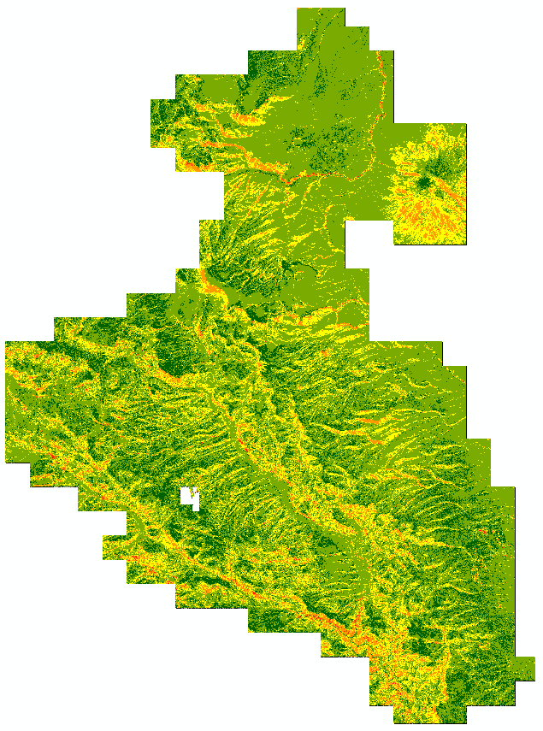

Introduction

In this exercise, you will use a couple of the layers created in the Surface Analysis exercise and a canopy cover raster to create a simplistic landslide hazard map. To create a landslide hazard map, you will utilize the reclassify tool and the raster calculator to identify characteristics of the surface and canopy cover rasters that impact landslide hazards. By creating this simplistic model it is our hope that you will begin to see the potential applications of lidar derived high resolution DEMs for a variety of land management objectives.

**Required Data**

* **RioTusas_CanopyCover_10m.img –** This will be used as a surrogate for vegetation in the landslide hazard model
* **RioTusasSl.img** – This is the slope layer derived in exercise 2: Surface Analysis
* **RioTusas_Aspect.img** – This is the aspect layer derived in exercise 2: Surface Analysis

**Prerequisites**

* Install ESRI ArcMap on computer and have basic understanding of how to use the software
* Completed Exercise 2: Surface Analysis

Table of Contents

Part 1: Reclassify the Slope, Aspect, and Canopy Cover Rasters 3

Part 2: Combine Weighted Slope, Aspect and Cover Rasters to Create Hazard Map 8

Appendix 1: Map Algebra 10

1. Reclassify the Slope, Aspect, and Canopy Cover Rasters
   1. Open ArcMap and Add Data
      1. Start ArcMap by clicking on the Start button and navigating to **All Programs, ArcGIS,** then **ArcMap10.**
      2. Click the **Add Data** button (see following graphic).

Add data button in ArcMap


* + 1. Navigate to your outputs folder and add layers that you created in the Surface Analysis Introductory Exercise: **RioTusas_Aspect.img** and **RioTusasSl.img.**
  1. Activate Spatial Analyst extension and Open ArcToolbox
     1. If you haven’t already, activate the **Spatial Analyst** extension. From the **Customize** menu, choose **Extensions.**
     2. In the **Extensions** dialog, put a checkmark next to **Spatial Analyst**, this makes that extension available to use.
     3. Click **Close** to dismiss the **Extensions** windows.
     4. If the **ArcToolbox** window is not visible, click the **ArcToolbox** button (see following graphic) and dock the window next to your **Table of Contents.**

ArcToolbox in ArcMap

* 1. Determine slope classes
     1. Double click **RioTusasSl.img** in the table of contents and go to the **symbology** tab.
     2. Navigate to the **Classified** section (left side of the dialog box) and then click the **Classify** button.
     3. The default method should be set to **Natural Breaks (Jenks),** but if it isn’t, change it to Natural Breaks.
     4. Set the number of **classes** to **6. T**he dialog should look similar to the image below.

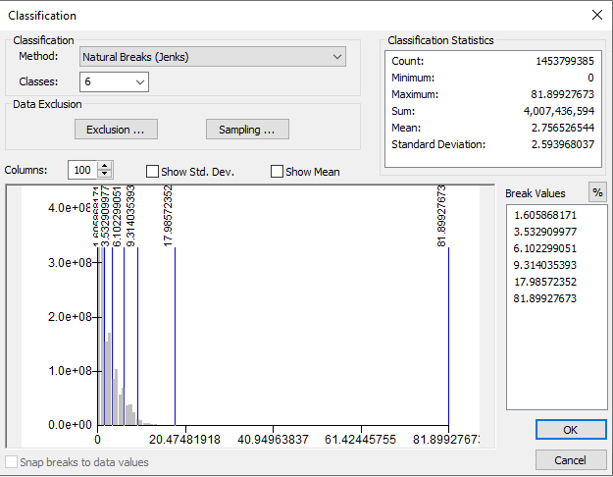

* + 1. Click **OK** and close the Layer Properties window.
  1. Reclassify the Slope Raster
     1. Navigate to **Spatial Analyst tools, Reclass, then Reclassify** and click on the tool.
     2. Select your slope layer as the input raster or drag the slope layer into the dialog box to populate the classes automatically. Some changes need to be made to these classes.
     3. First, we need to start the first class at **0**. Keep NoData as NoData.
     4. Change the last class so that it goes up to **89**. This ensures all the values are being included.

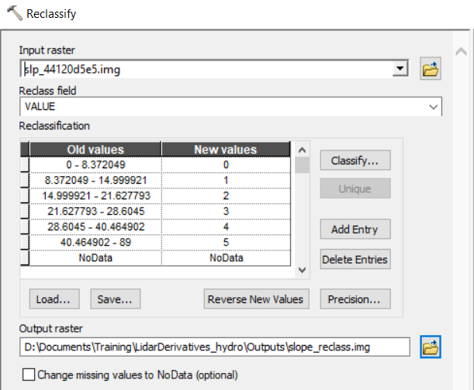

* + 1. Name the output **SlopeReclass.img** and put it in the **Outputs** folder (…ProjectData\Outputs). See the above image for the example tool dialog, and below for what the output looks like. Output colors may vary.

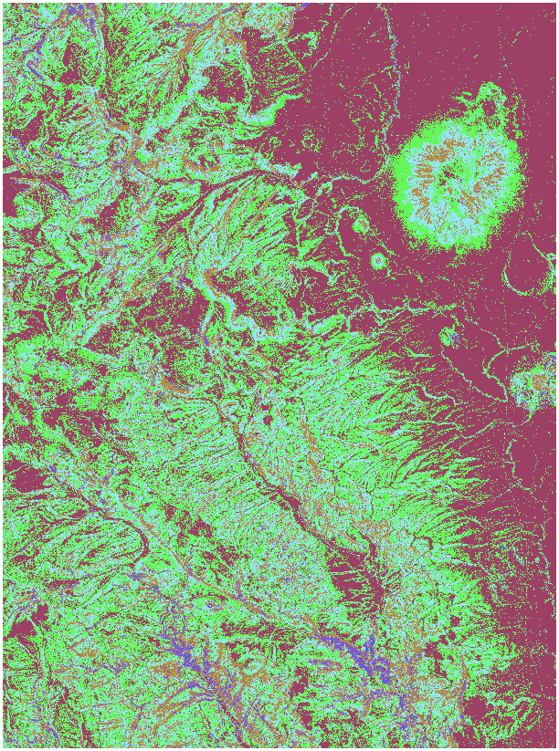

* 1. Reclassify the Aspect Raster
     1. Open the **Reclassify** tool.
        1. You will now reclassify the aspect raster so that southern facing slopes (150-210 degrees) have a greater probability of a landslide.
     2. First, click **Classify** to the right of the New Values column, change the Classes number to **8** and click **OK**.
     3. Now refer to the following graphic for what values to **reclassify.**
        1. Note that in order to properly enter the Old values, you need to insert a space on either side of the dash (-). This makes it clear that you are referring to a range of values.
        2. Make sure the **NoData** values are set as **NoData.**

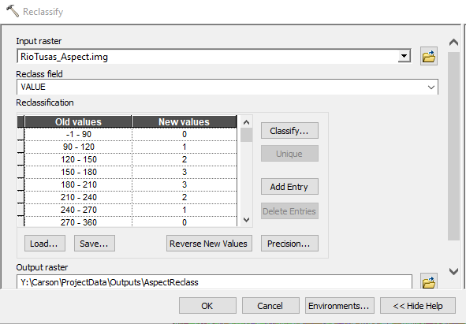

* + 1. Name the output **AspectReclass.img** and save it in the **Outputs** folder.
    2. Click **OK** to run the tool. The results should look similar to the image below.

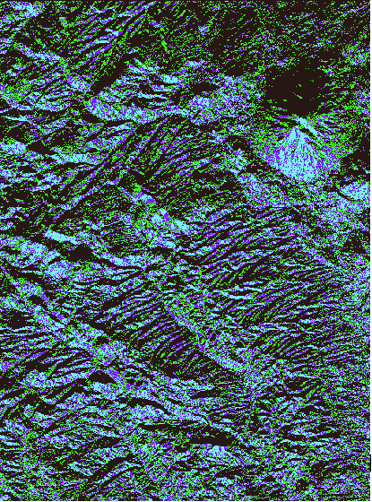

**Note:** Reclassifying a raster is a useful tool when you want to reduce the amount of data you have in a raster or when you want to reclassify values as NoData values.

* 1. Reclassify the Canopy Cover Layer
     1. Add the **RioTusas_CanopyCover_10m.img** (…ProjectData\Lidar) layer to your ArcMap.
     2. Double click the **RioTusas_CanopyCover_10m.img** layer and click the symbology tab.
     3. As before, use **6** classes and **Natural Breaks** to classify the Cover raster.
     4. Open the **Reclassify** tool and use **RioTusas_CanopyCover_10m.img** as the input.
     5. Change the largest value to **100** so all pixels are included.
     6. Now we need to invert the new values for this re-classification; areas with low vegetation are more susceptible to landslides, so the first category that includes the lowest percentage of cover should be reclassified as a **5.**
     7. Move down through the rest of the classes and reclassify them so that the classes match those seen below.

Reclassify canopy cover:
0-11 : 5
11 - 28 : 4
28 - 43 : 3
43 - 57 : 2
57 - 71 : 1
71 - 100 : 0

* + 1. Save the output in the **Outputs** folder and name it **CoverReclass.img**. Click **OK**.
       1. Note that the coloration of your output will most likely vary.

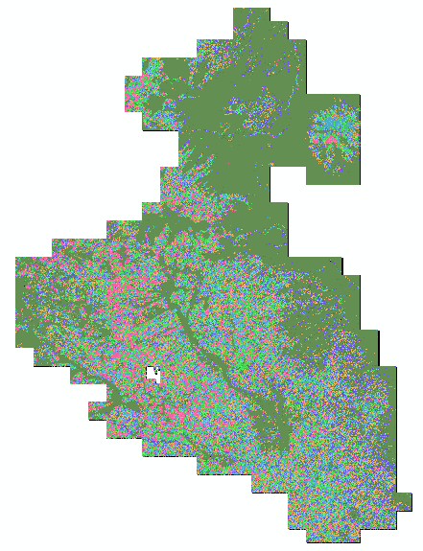

1. Combine Weighted Slope, Aspect and Cover Rasters to Create Hazard Map

It is important to note before moving forward that this is an exploratory analysis of the actual potential landslides in this area. A more robust method with more variables would be ideal for a detailed analysis. The purpose of this exercise is to showcase raster geoprocessing techniques and how they can be used with lidar derived data.

* 1. Use Raster Calculator to Create a Weighted Hazard Map
     1. Navigate in the toolbox to **Spatial Analysis, Map Algebra,** and open the **Raster Calculator** tool (for more info on raster calculator see Appendix 1).
     2. Enter the following script using either the buttons on the tool or your keyboard. **("CoverReclass.img" * .2) + ("AspectReclass.img" * .2) + ("SlopeReclass.img" * .6)**
     3. Save the output to your **Outputs** folder and name it **LandslideHazard.img**. Click **OK**
     4. To better view the output, open **Symbology** and classify it into **5** **Equal Interval** classes and change the color ramp (see example output below).



You may want to view the landslide hazard map in conjunction with the NAIP imagery to see the type of areas that are most hazardous. In the future, you could add in data about rivers and roads which also affect the potential for landslides.

**Congratulations**! You now know how to use surface layers in a basic landslide hazard map. This type of analysis may be useful in other projects you have.

Appendix 1: Map Algebra

Map Algebra is a simple and powerful algebra with which you can execute all Spatial Analyst tools, operators, and functions to perform geographic analysis. The Map Algebra used in Raster Calculator has a syntax, or a set of rules, that must be followed to create a valid expression. In its most basic form, an output raster is specified to the left of an equal sign (=) and the tools, operators, and their parameters are on the right. Map Algebra provides a rich suite of tools for performing comprehensive, raster-based spatial analysis and modeling. Map Algebra expressions can consist of a single tool or operator but can also consist of multiple tools and operators. See the following table for more information on how to access various tools in different versions of ArcGIS.

**For Example: Con (“dem_44120d5e5” >= 2000, “dem_44120d5e5”, 0)**

|  | **ArcGIS 9.3** | **ArcGIS 10.x** |
| --- | --- | --- |
| **Spatial Analyst** | Tools and operators accessed through ArcToolbox and Spatial Analyst Toolbar | Tools and operators accessed through ArcToolbox, Raster Calculator, Spatial Analyst Toolbar, and the Python window. |
| **Map Algebra** | Accessed through the Raster Calculator, and Single Output Map Algebra (SOMA) & Multiple Output Map Algebra (MOMA) tools in ArcToolbox | Map Algebra is accessed through the Raster Calculator, the Python window, or any Python Integrated Development Environment (IDE). |
| **Raster Calculator** | Accessed through the Spatial Analyst toolbar. Contained a button-like calculator interface to run single or multi-line Map Algebra expressions. | Accessed through the Spatial Analyst > Map Algebra toolbox. Retains the button-like calculator interface and used to implement simple and complex Map Algebra statements. |

This statement will output a raster called 2000_dem.tif where cells that have values greater than 2000 will be selected and set to that of the input values of the original DEM; otherwise the value will be set to 0.