Last Updated: January 2021
Version: Arc 10.7

Exercise 2a

Identifying and Digitizing Roads
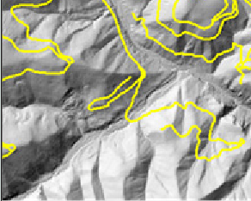
Introduction
Lidar derived DEM products can be used as background images for heads-up digitization to produce more accurate and complete road networks than what can be achieved with just aerial photos. This is because lidar has the unique capability to penetrate forest canopies and thus provide a more accurate depiction of the ground in forested areas. Accurate road databases are critical for planning future roads, analyzing stream-road interactions, watershed management, and other management applications. This exercise will teach you how to heads-up digitize roads by using DEM products and aerial imagery.
Objectives
- Identify roads using a variety of geospatial data layers
- Create a shapefile and use it to digitize and attribute roads
Required Data
- RioTusas_DEM.img
- RioTusas_NAIP2018.tif
- Roads.shp – reference layer of digitized roads
Prerequisites
- ESRI ArcMap installed on computer
- Basic understanding of how to use ArcMap.
Table of Contents
Part 1: Load Data Layers Into ArcMap 3
Part 2: Create Hillshade Layers 3
Part 3: Compare Image Layers 6
Part 4: Create New Shapefile 9
Part 5: Digitize Roads 10

- Load Data Layers Into ArcMap
    - Launch ArcMap from the start menu by clicking Start, Programs, ArcGIS, ArcMap 10.x.
    - Click the Add Data button and navigate to the ProjectData\ folder within your course data folder.
    - Add the RioTusas_DEM.img layer.
    - Add the Roads.shp layer and make sure it is above the DEM in the table of contents.
    - Notice that the roads in the shapefile aren’t visible or apparent on the DEM.

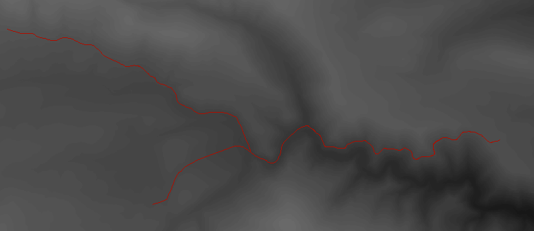
- Create Hillshade Layers
    - On the ArcMap main menu, click Windows, then Image Analysis to turn on the Image Analysis tool (see following graphic).

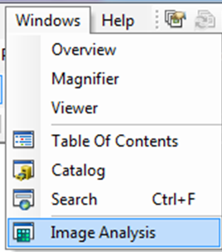

Note: The Image Analysis Window is a powerful tool that allows users to explore their raster based images in a quick and convenient manner. The functionality built into this window are available elsewhere within ArcMap but the Image Analysis Window generates all products within RAM which enables the quick display and creation of the most commonly used raster products.
    - The Image Analysis tool will open. Dock it if desired; you may need to click and drag the bottom of the window down to view the entire tool. Most of the tools will be greyed out.
    - In the top window, click on the DEM_1meter.tif layer. Notice that when you do, most of the tools within the Image Analysis Window will now be available.

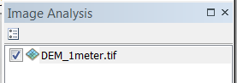
    - In the Processing section click on the Add Functions button.
    - In the Function Template Editor dialog, right-click on the DEM image at the bottom of the Function Chain, click on Insert Function, and select the Hillshade Function (see below).

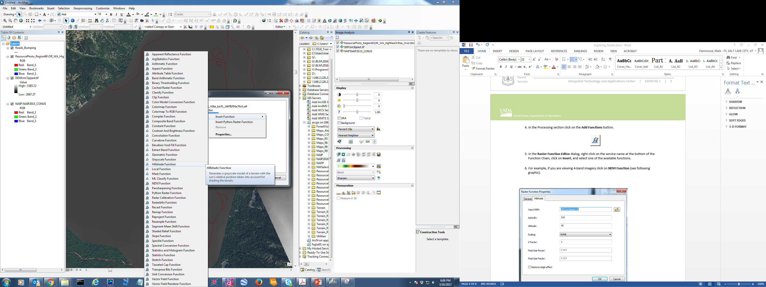
    - In the Raster Function Properties dialog, make sure the Azimuth field value is 315. An azimuth of 315 means the hillshade will be illuminated from 315 degrees (northwest). You may leave the other settings at their default.
    - Click OK (see below).

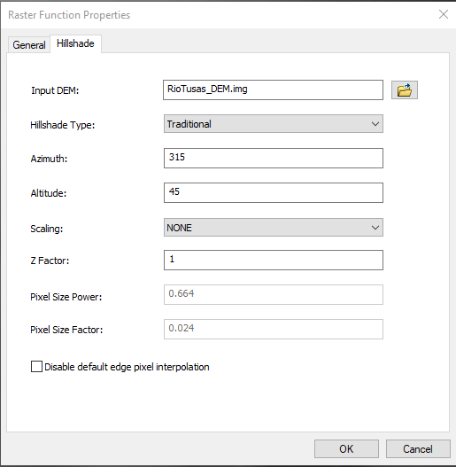
    - Click OK in the Function Template Editor. You should now see the hillshade layer in the table of contents.
    - In the table of contents, double-click the hillshade layer to open Layer Properties. Under the General tab, change the Layer Name to Hillshade315.tif (see below).
      - Alternatively, select the layer in the table of contents, then click it one more time to edit the name without opening the Layer Properties window.

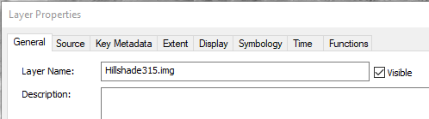
    - Repeat steps 4 – 8 to create two more hillshades with azimuths set to 45 and 180.
    - You should now have three hillshade images with azimuths of 315, 180, and 45 (see below).

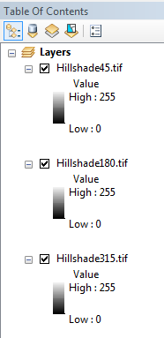
- Compare Image Layers
Next you will compare the data layers based on how visible the roads are on them. You will first add NAIP imagery and then use given coordinates to explore three areas.
    - Click the Add Data button, then navigate to your digitizing roads folder and add RioTusas_NAIP2018.tif.
    - On the Tools toolbar, click the Go To XY button (see below).
    - On the Go To XY tool, click the Units button then select Decimal Degrees (see below).

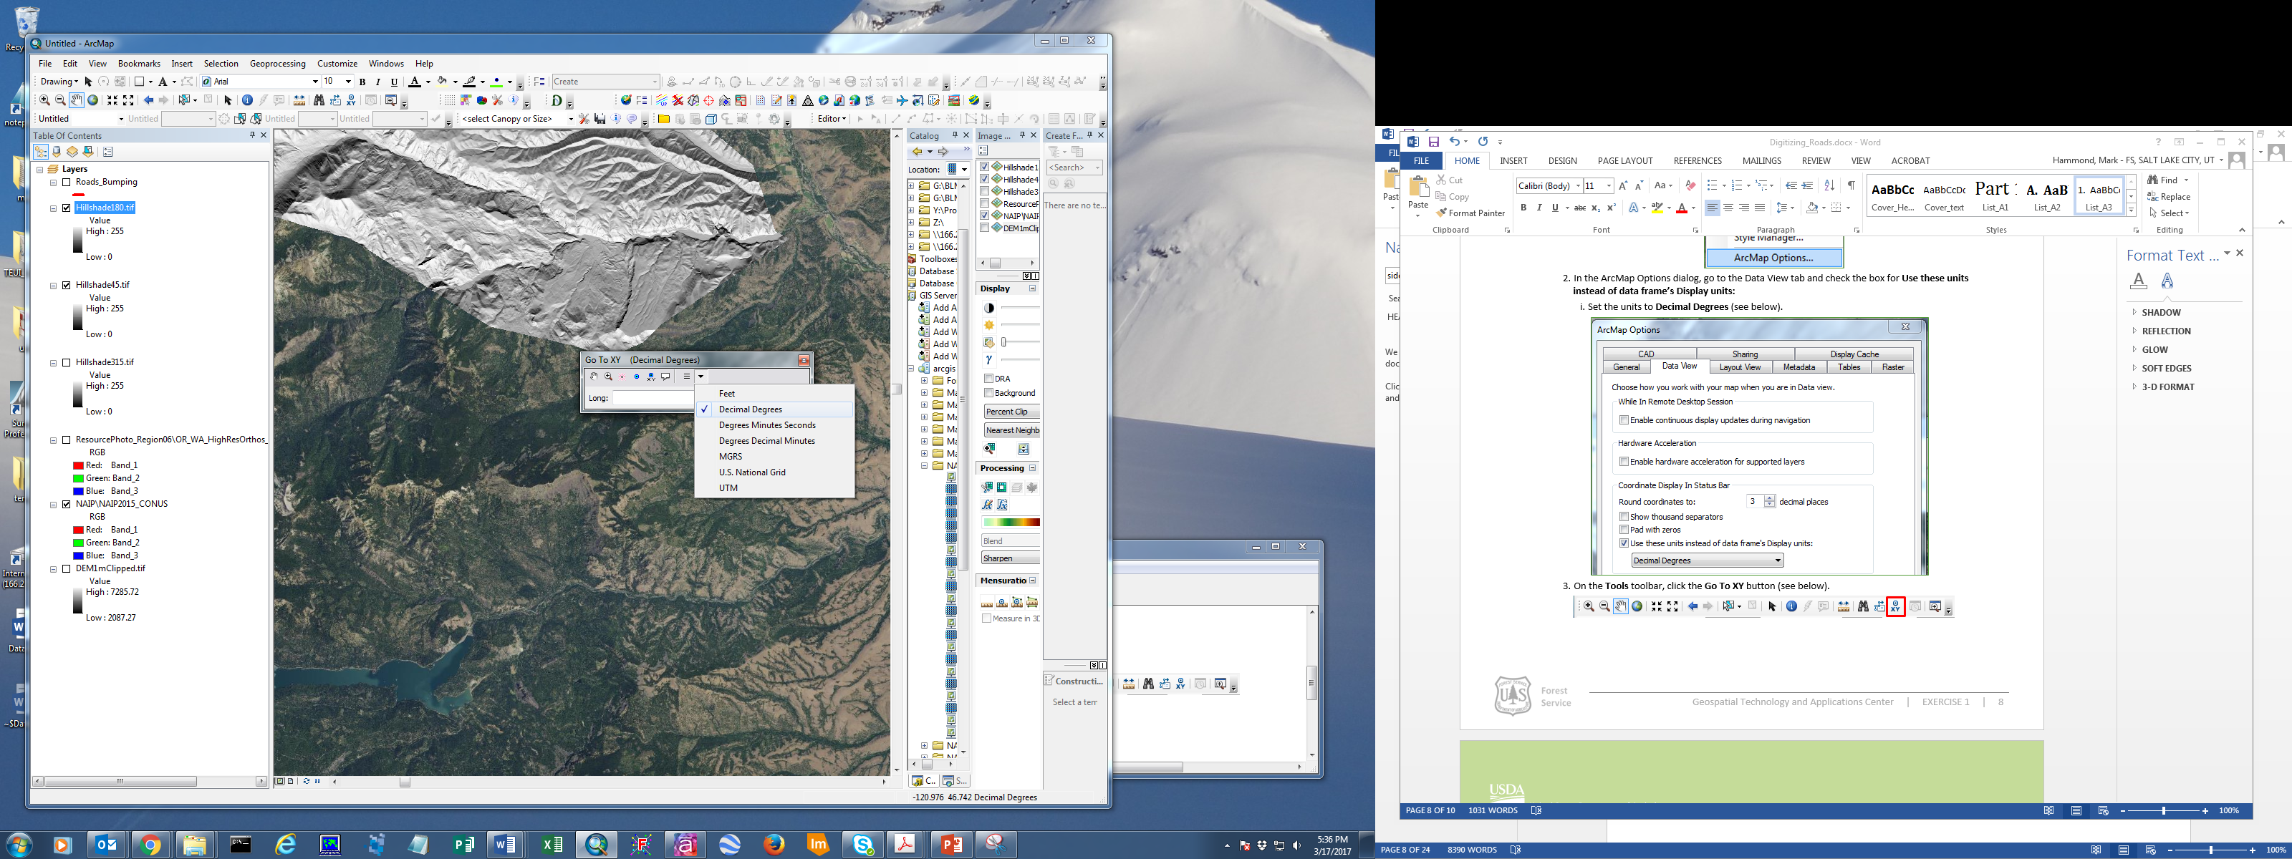
    - In the Long: field enter -106.118332 and in the Lat: field enter 36.731195.
    - Click the Zoom To button (see below).

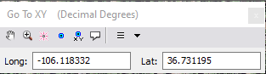
    - Notice the road in the middle of the scene at the bottom of the gully. Click on the Roads.shp layer to see exactly where this road is.

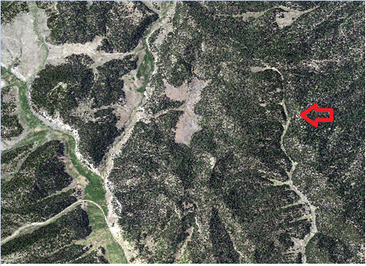
      - Turn off all layers except the NAIP imagery (click the check box next to the layer in the table of contents) and notice how the road is somewhat difficult to see.
      - Look at the road on the Hillshade 180 layer. It’s a little easier to see than in the NAIP.
      - Look at the road on the Hillshade 45 layer.
      - Look at the road on the Hillshade 315 layer. Notice how much better the road shows up on this layer than all the others (see below).

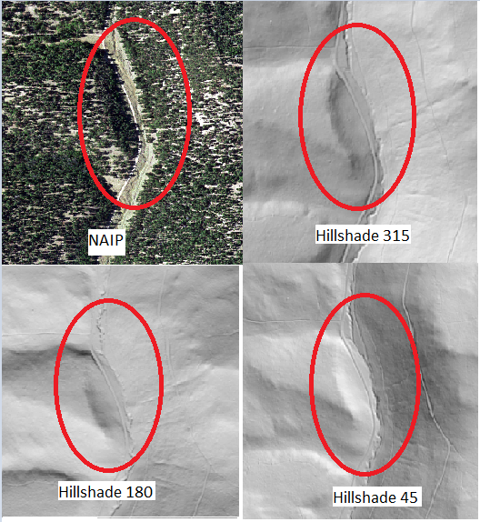
    - Open the Go to XY tool again and enter the following coordinates:
      - Long: -106.107618
      - Lat: 36.617645
    - Click the Zoom To button and study the roads layer in this area and compare how visible the roads are in the NAIP and hillshade images.
      - Can you find sections of road that are more visible in the NAIP than the hillshades?
    - In the Go to XY tool enter the following coordinates and click the Zoom To button:
      - Lont: -106.123984
      - Lat: 36.853896
    - Which hillshade layer provides the best visualization of roads in this area?
- Create New Shapefile
Before you can start digitizing roads you must create a shapefile.
    - Open the ArcCatalog window that is available within ArcMap. It may be docked to the side of your ArcMap session. If you don’t see it, click the ArcCatalog button at the top of your ArcMap (see below), then dock it to the side of your window.

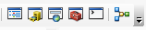
    - In the ArcCatalog pane, navigate to your course data folder (…ProjectData\Vector).
    - Right-click the folder, click New, then select Shapefile…
    - In the Name field, type a name like Forest Roads.
    - Next to Feature Type, select Polyline.
    - Click on Edit below the Spatial Reference section.
    - Click the Add Coordinate System button then click Import (see below).

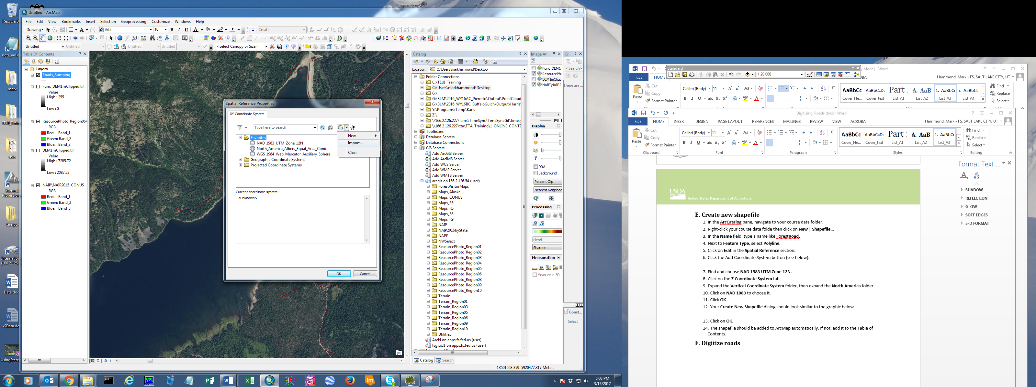
    - Navigate to your course data folder and add the RioTusas_DEM.img layer. This applies the spatial reference of the file you chose to the new shapefile.
    - Click OK.
    - Your Create New Shapefile dialog should look similar to the graphic below.

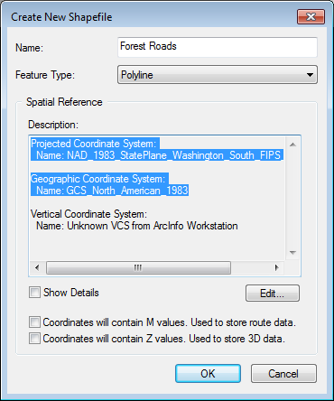
    - Click on OK.
    - The shapefile should be added to ArcMap automatically. If not, add it to the map.
- Digitize Roads
Now you have the images and shapefile ready to digitize roads.
    - Use the NAIP and all three hillshade layers to find roads to digitize.
    - In the Table of Contents, right-click on the shapefile you just created then click Edit Features | Start Editing (see below).

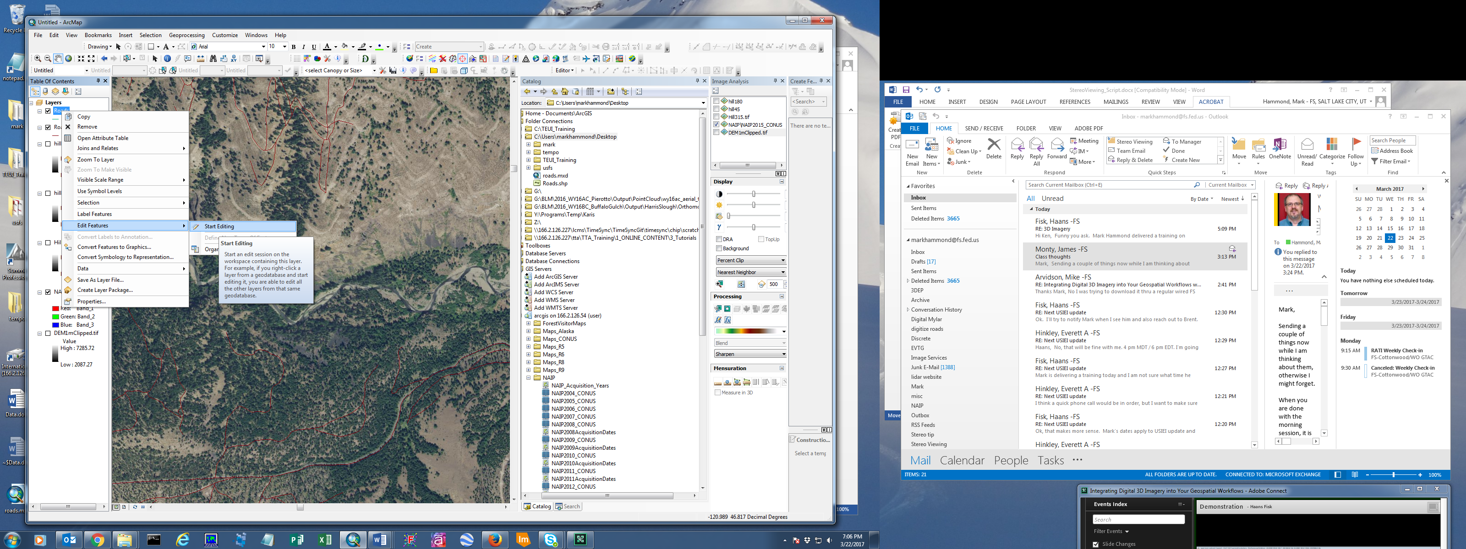
    - Open your Editor toolbar by going to Customize | Toolbars and then place a check next to Editor.

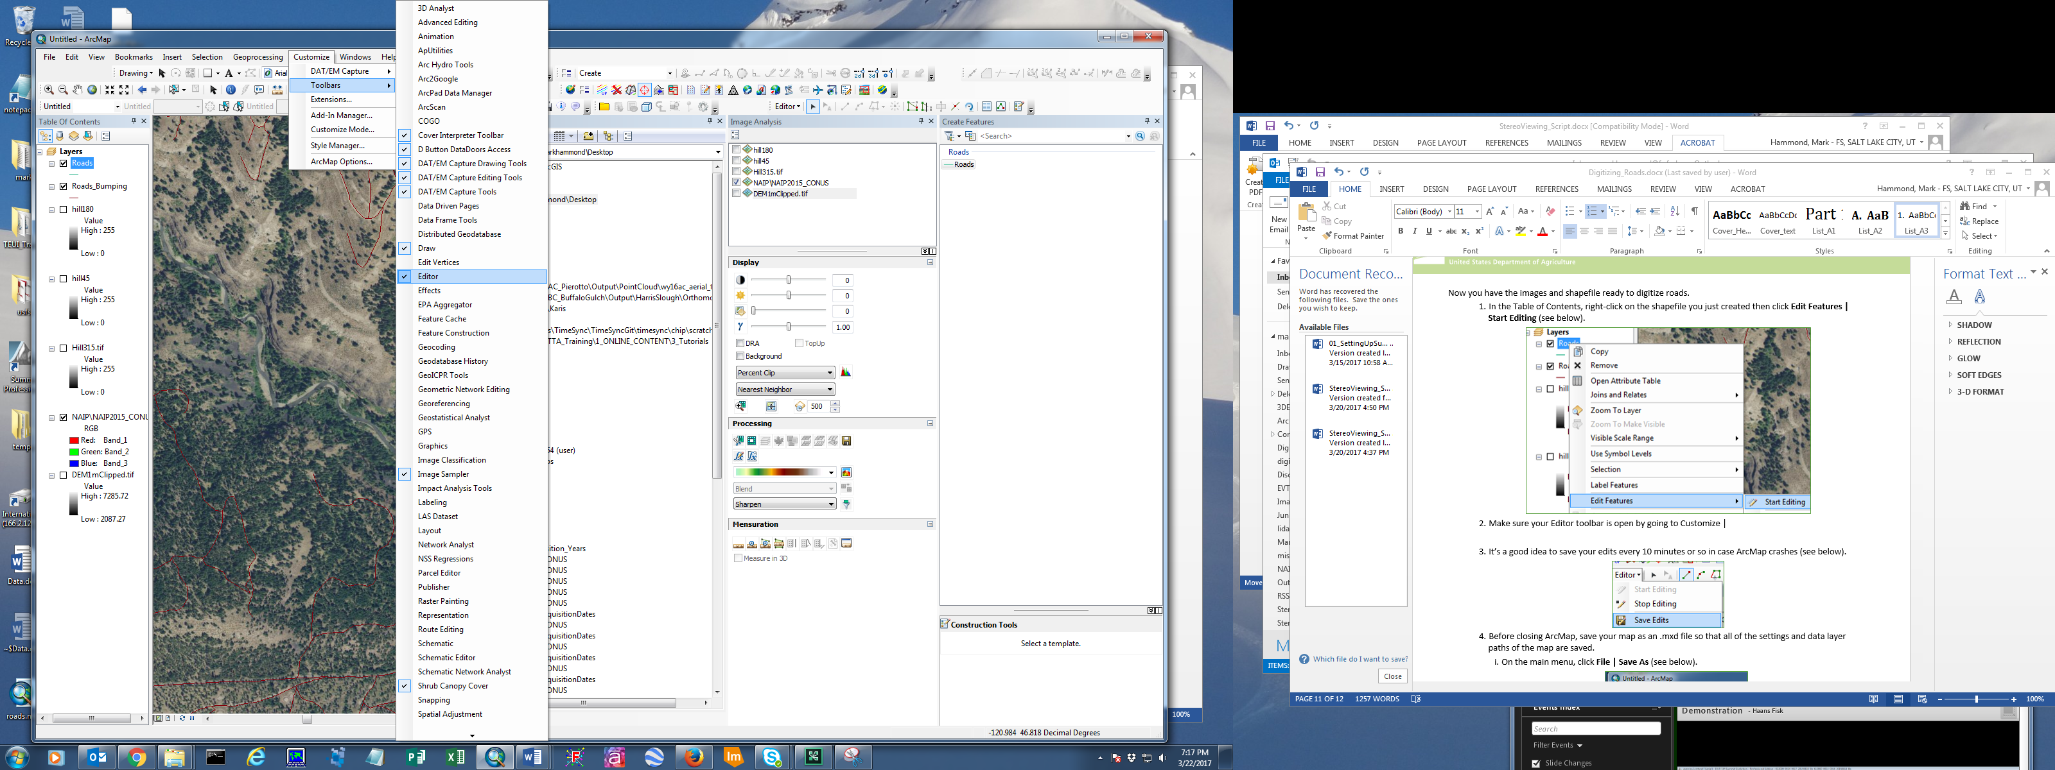
    - Click the Editor drop-down menu, then go to Editing Windows and click Create Features to open the Create Features window.

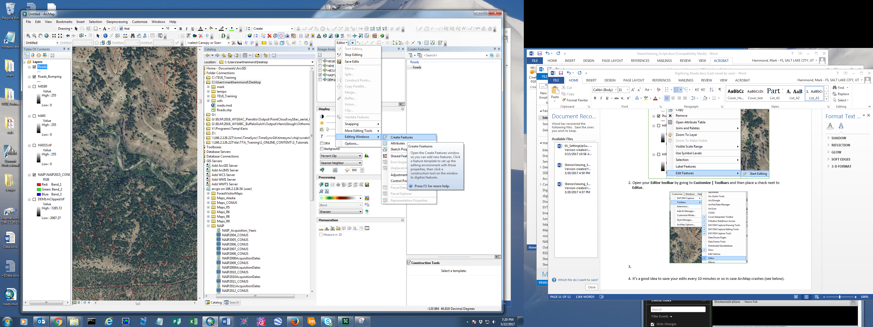
    - In the Create Featuers window, click on your road shapefile, then in the Construction Tools window below click Line (see below).

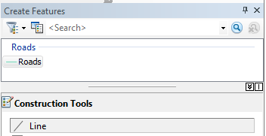
    - Your cursor should now be a cross and you can start digitizing a road by left-clicking. A higher zoom level is often desireable for digitizing features.
      - Keep left-clicking to create vertices in the polyline (see below).

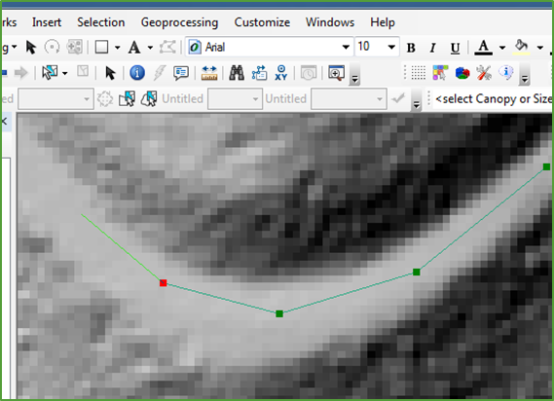
    - Double left-click to finish your edit.
IMPORTANT: It is essential to properly attribute your newly digitized roads so that they can be included in Forest Service’s infrastructure database (a.k.a. “Infra”). The attribution process for new line work is outlined in the following document: http://fsweb.r6.fs.fed.us/eng/travel_routes/user_board/Infra/TRDD_NBR_Version_3.2_August2015.pdf
    - It’s a good idea to save your edits every 10 minutes or so in case ArcMap crashes. Click the Editor toolbar dropdown menu then Save Edits (see below).

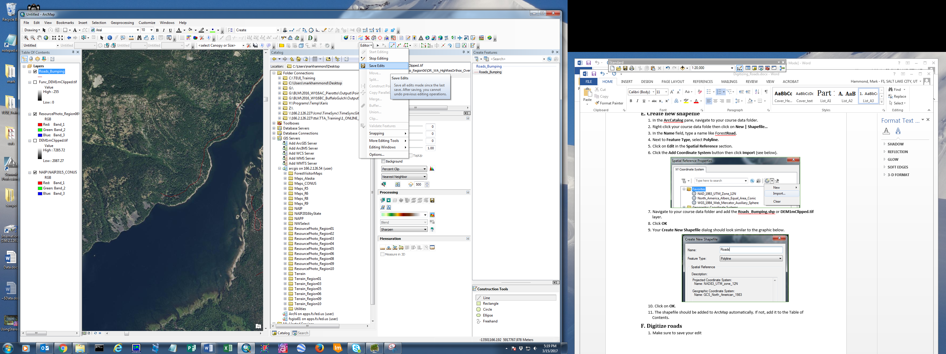
    - If desired, you can save your map as a .mxd file so that all of the settings and data layer paths of the map are saved.
      - On the main menu, click File | Save As (see below).

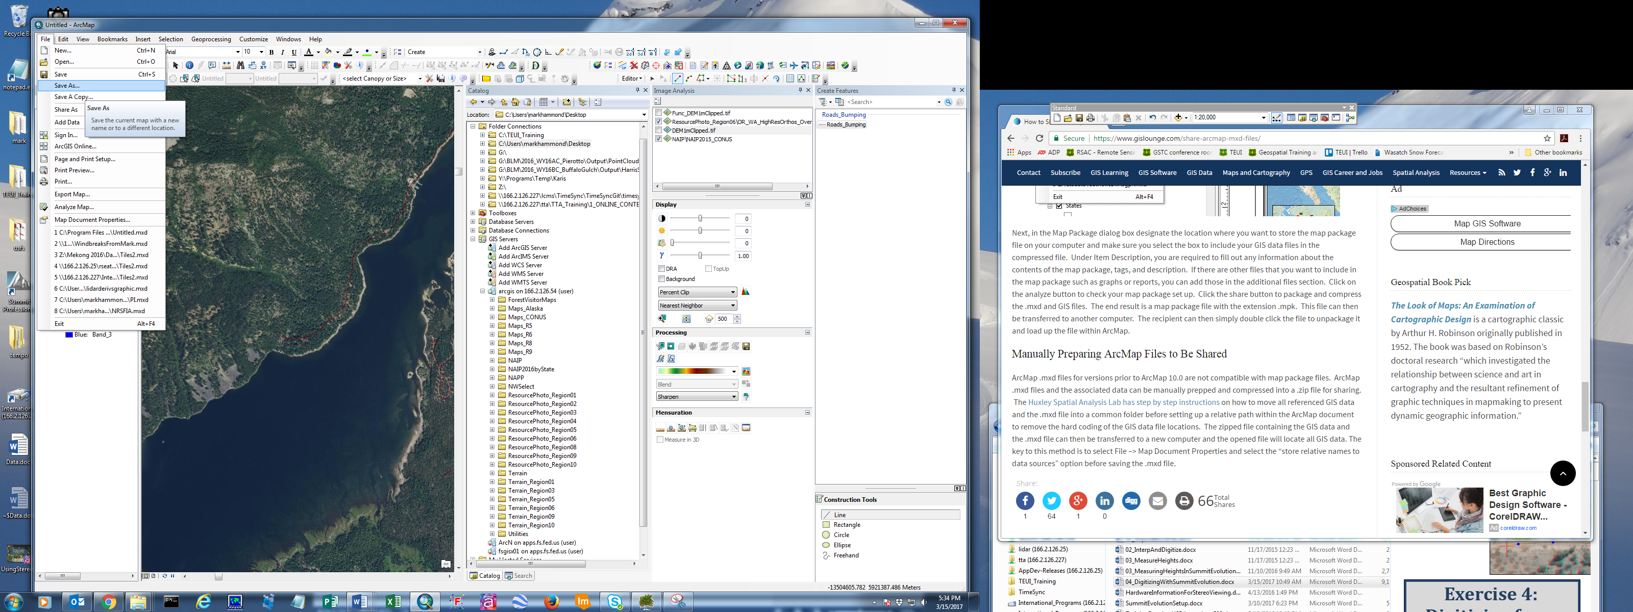
      - In the Save As dialog, enter a map name and make sure the Save as type field is set to ArcMap Document (*.mxd). See below.

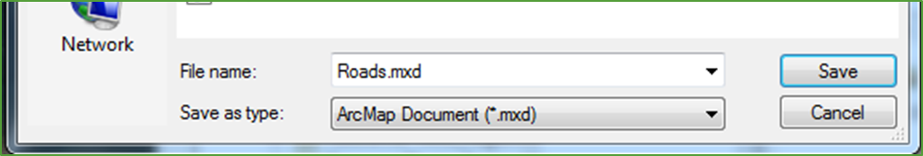
Congratulations! You have completed this exercise, which has taught you the tools you need to create hillshades from a DEM to identify features on a landscape.

