Last Updated: March 2020

Version: ArcMap 10.5

# EXERCISE 3a

# Prepare Lidar Bare Earth DEM Tiles

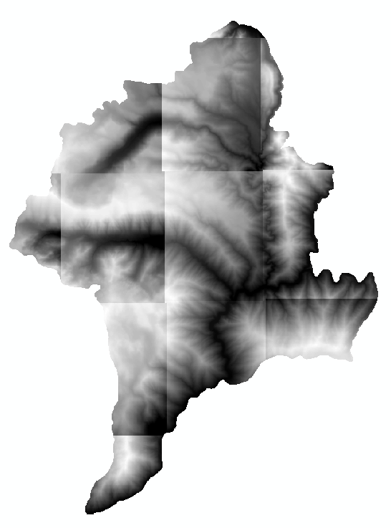

Introduction

When you receive your lidar data, it may or may not come as a seamless bare-earth raster image. To perform any analysis involving water, it is essential to have a seamless surface to work with and calculate flow over. In this exercise, you are given 12 separate bare earth raster tiles that you will need to prepare for hydro modeling by mosaicking them together and then clipping them down to a more workable dataset. This is a very common remote sensing process, as lots of remotely sensed data is broken up into tiles to reduce individual file size and thus improve the efficiency of transferring files.

Objectives

* Mosaic and Clip DEM data in preparation for hydro modeling workflow

Required Data

* **12 Bare Earth Rasters (be_xxxxxxxx)**

Prerequisites

* It is highly recommended that you are somewhat proficient using ArcMap however it is not necessary for this exercise to have an extensive knowledge of ArcMap.

Table of Contents

Part 1: Set up ArcMap 3

Part 2: Mosaic DEMs 3

Part 3: Create Hillshade From Mosaicked DEM 4

Part 4: Clip DEM and Hillshade 5

1. Set up ArcMap
   1. Start ArcMap
      1. If prompted with a dialog box asking whether you would like to open a new map or an existing map, choose a new empty map and click **Ok**.
   2. Add the bare earth DEMs
      1. Click the **Add Data** button and Navigate to the **…\Data\Track1_BareEarthDerivatives\HydroData\BareEarth** folder where the Bare Earth grids are saved, select it, and click **OK**.
      2. Highlight all 12 Bare Earth (be_) grids and click **Add**. We mill Mosaic the bare earth grids to a single raster in the next section.

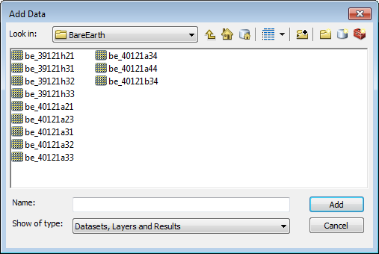

1. Mosaic DEMs
   1. Mosaic Tool
      1. Activate the ArcToolbox (see button below) and navigate to **Data Management**, **Raster**, **Raster Dataset**, then select the **Mosaic To New Raster** tool.

screenshot of toolbox

* + 1. Include all 12 bare earth grids for the **Input Rasters**.
    2. Save it to your **Outputs** folder and set the **Raster Dataset Name with Extension** to “**be_storrie.img**”. Don’t forget to type the *.img* extension. This will force the output to be an ERDAS Imagine image file format. If you don’t type the extension the output will be an ESRI grid.
    3. Make sure to change the **Pixel type** to match that of your input rasters (i.e. **32 bit floating point**).
    4. Set the **Number of Bands** to “**1**”.
    5. Leave all other settings at their defaults and click **OK** to run the mosaic. The process will take a few minutes. Please be patient.
    6. When the process is finished, add the **be_storrie.img** to ArcMap. If prompted to create pyramids, choose **Yes**.
    7. The raster will appear all gray when you first add it. This is because there are no statistics calculated for it and it is stretching the color ramp across the entire 32 bit floating point range of values (which is 0 through 4,294,967,295 or (232 - 1) potential values).
    8. Double click the be_storrie.img raster to open the **Layer Properties**.
    9. Go to the **Symbology** tab and under Stretch > Type: (lower portion of the dialog window), choose **Standard Deviations.** A window will appear asking you to **Compute Statistics**. Click **Yes**.
    10. Then click **OK** to close the Layer Properties. Your mosaicked raster should look like the following graphic.

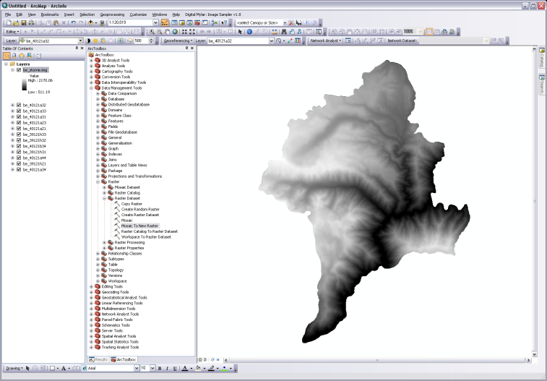

1. Create Hillshade From Mosaicked DEM
   1. Hillshade Tool
      1. From the ArcToolbox navigate to the **Spatial Analyst** **toolbox**, **Surface,** and then select the **Hillshade** tool.
      2. Set the **Input Raster** to the be_storrie.img.
      3. Save it to the **Outputs** folder and name it something like **hillshade.img**.
      4. Click **OK** to run the process. Be patient—these datasets are large and take some time to process. Your hillshade should look like the one in the following graphic.
      5. Take a moment and explore the hillshade raster you just created. Get a feel for the data and the lay of the land.
      6. 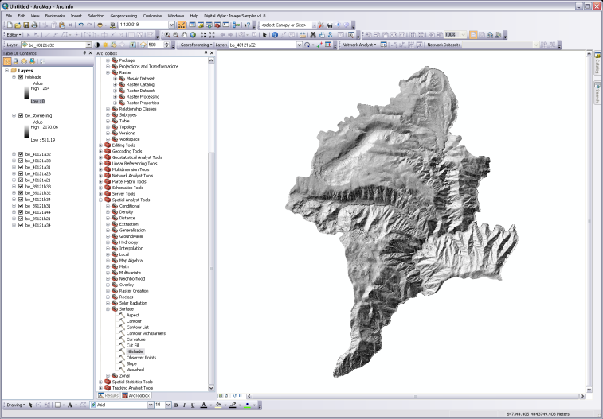

**Note:** If you need to create smaller watersheds because your dataset is too large to use all at once, you may want to think about using known delineations such as the HUC 12 units provided by NRCS if available. By using these for delineating larger watersheds, they should seamlessly tie in with other higher level NHD layers (e.g., HUC 6, HUC 8).

1. Clip DEM and Hillshade
   1. Clip Dem and Hillshade
      1. First let’s add a shapefile to clip the data to. Click the **Add Data** button and navigate to the **HydroData\Shapefiles** folder. Add the **Clip.shp**. You will clip the mosaicked DEM and hillshade to this boundary. It will aid in speeding up processing time for the remaining exercises.
      2. From ArcToolbox navigate to **Data Management Tools > Raster > Raster Processing > Clip**. Let’s first clip the be_storrie.img to the Clip.shp.
      3. Input Raster should be **be_storrie.img.**
      4. Output Extent should be **Clip.shp.**
      5. Use Input Features for Clipping Geometry **should be checked**.
      6. Name the Output Raster Dataset **be_storrie_clip.img** and save it in the **HydroData\BareEarth** folder.
      7. Click **OK** to run the process.
      8. Repeat **steps 1-7** to clip the hillshade (name it appropriately).

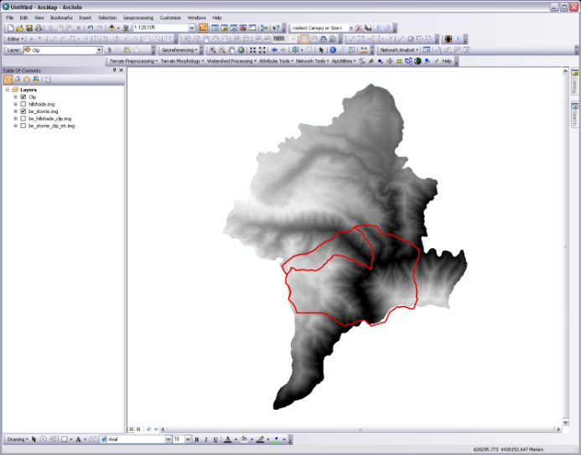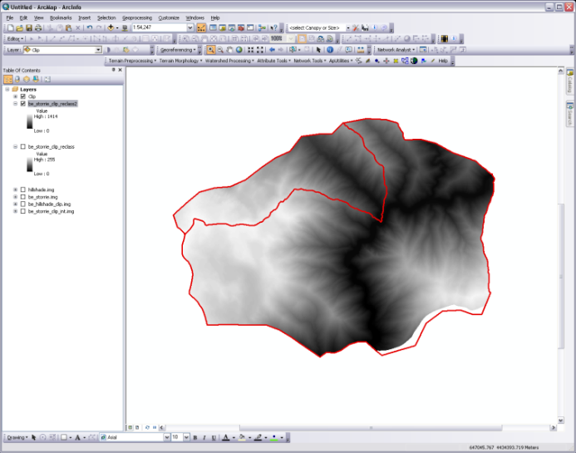

* 1. Convert floating point raster to integer
     1. From **ArcToolbox** navigate to **Spatial Analyst**, **Map Algebra**, then select **Raster Calculator**.
     2. From the **Calculator**, find the **Int** tool and double click it (from the panel on the far right).
     3. With the cursor inside the parentheses, double click the **be_storrie_clip.img** raster.
     4. Give the output raster a proper name and location (e.g. be_storrie_clip_int.img) and click **OK** to run.

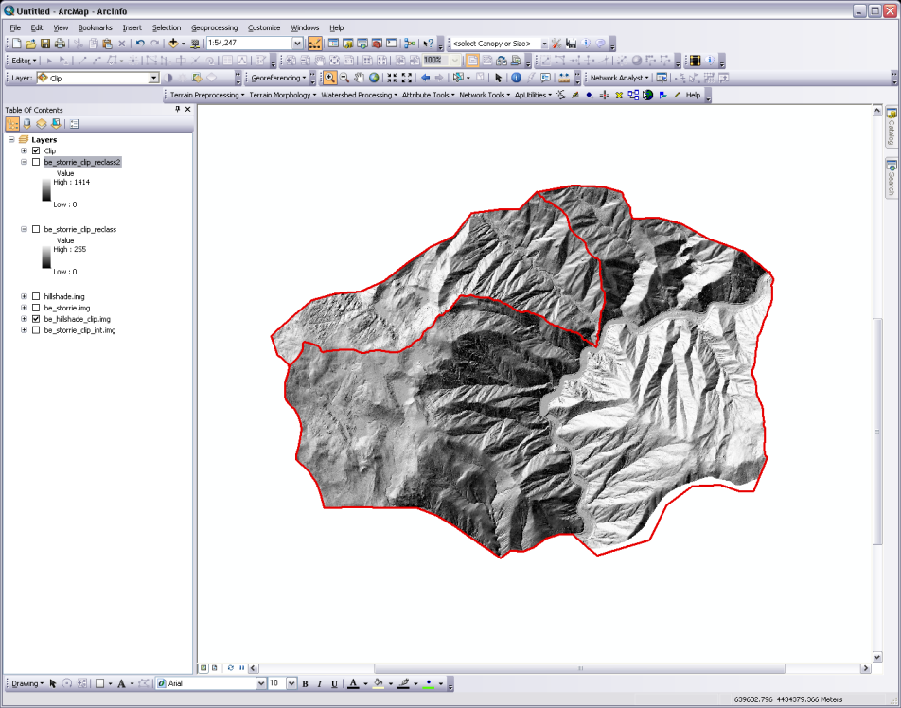

**Congratulations!** You have completed this exercise, which has taught you the tools you need to prepare a set of bare earth tiles for hydro modeling. You will use your final outputs from this exercise as inputs to the next exercise. You may need to apply a similar workflow when working with other raster datasets, such as NAIP or Landsat data.