Last Updated: March 2020

Version: ArcMap 10.5

# EXERCISE 4a

Prepare Lidar Bare Earth DEM for Hydro Modeling

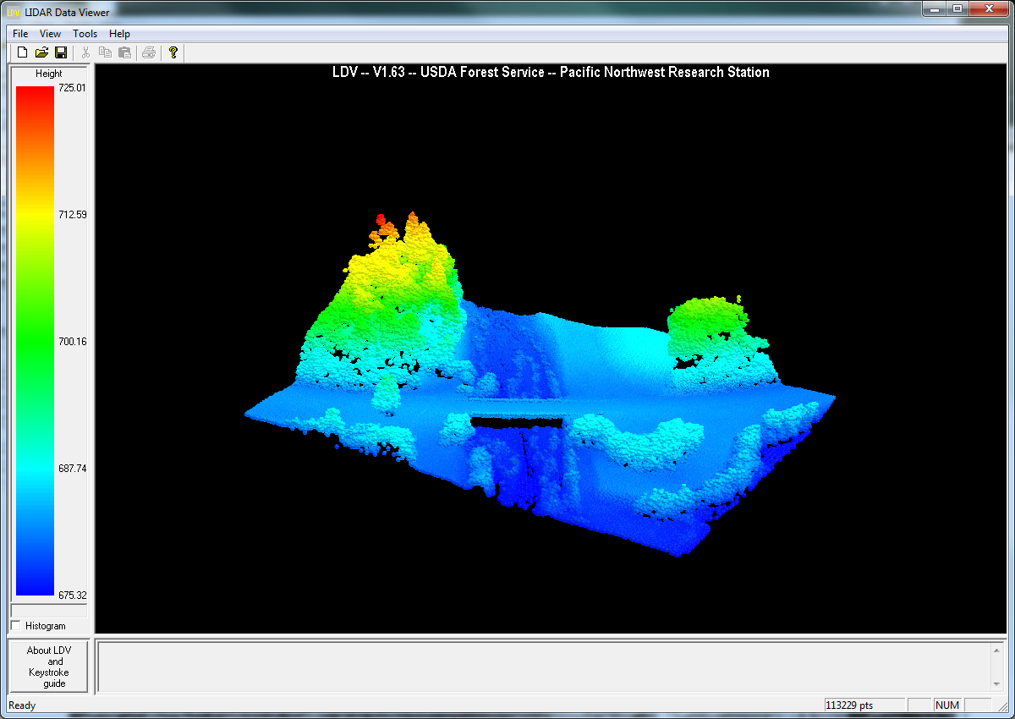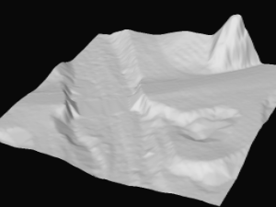

**Introduction**

In this exercise you will prepare your lidar bare earth DEM for further analysis by channel busting “false dams” such as culverts, evaluating it for sinks, depressions and defects, and fixing them using Spatial Analyst tools. By removing, or “burning in”, culverts or bridges from the DEM, you are ensuring that the flowline that is generated in the following exercises is representative of the study area.

**Objectives**

* Utilize Spatial Analyst Tools to prepare DEM for flowline modeling workflow

**Required Data**

* **Be_storrie_clip_int.img—output from Exercise 3**
* **Be_hillshade_clip.img—output from Exercise 3**
* **Culverts.shp—shapefile containing locations of culverts**
* **NF_FeatherRiver.img— river raster**

**Prerequisites**

* Spatial Analyst Extension- activated in ArcMap

Table of Contents

Part 1: Setup Workspace 3

Part 2: Lidar Bare Earth DEM hydro-enforcing 4

Part 3: Burn Culverts Into DEM 6

Part 4: Fill Sinks in CulvDEM 8

1. Setup Workspace

When you receive your data from the lidar vendor, it may or may not come as a hydro-enforced DEM. When performing any hydrological analyses, it is critical that the DEM surface be properly prepared prior to beginning work. When you get a DEM you will begin by examining the DEM for defects (aka “false dams” and whether it has been hydro-enforced) and then perform some steps below to fix defects you find.

* 1. Start ArcMap
     1. If not already started, from the Start menu, navigate to All Programs > ArcGIS > ArcMap 10. Open Map.
  2. Activate Spatial Analyst extension and Open ArcToolbox
     1. If you haven’t already, activate the **Spatial Analyst** extension. From the **Customize** menu, choose **Extensions**.
     2. In the **Extensions** dialog, put a checkmark next to **Spatial Analyst**, this makes that extension available to use.
     3. Click **Close** to dismiss the Extensions windows.
     4. If the **ArcToolbox** window is not visible, click the **ArcToolbox** button (see following graphic) and dock the window next to your **Table of Contents**.
  3. Add clipped Storrie Fire data
     1. In ArcMap, click the **Add Data** button
     2. Navigate to the **Data/Track1_BareEarthDerivatives/HydroData** folder and locate the following datasets and add them:
        1. Be_storrie_clip_int.img
        2. Be_hillshade_clip.img
        3. Culverts.shp
        4. NF_FeatherRiver.img

**Note:** If you skipped Exercise 3a, the outputs are available in the DEM folder (Track1_BareEarthDerivatives\HydroData\DEM).

* + 1. If you have the Image Server activated, please access it and add the following: NAIP | NAIP2018_CONUS.
       1. To connect to Image Services in ArcMap, open your **Catalog**, expand **GIS Servers**, double click **Add** **ArcGIS Server**, click next in the initial dialog, and then enter this URL: [**https://image-services.gtac.fs.usda.gov/arcgis**](https://image-services.gtac.fs.usda.gov/arcgis). Clicking **Finish** will add the Image services link to the bottom of the GIS Servers list in ArcCatalog. For further help with adding the Image Server please refer to this link: http://fsweb.gtac.fs.fed.us/training-site/tutorials/Image%20Services%20and%20the%20Raster%20Data%20Warehouse/story_html5.html?lms=1

**Note:** Terrain preprocessing is one of the most important steps in data preparation for water resource analyses. The role of terrain preprocessing is twofold:

1. Develop hydro-enforced (e.g. corrected) DEM and its derivatives, primarily the flow direction and flow accumulation grids.

2. Develop a series of inter-related layers that improve the performance of hydrology tools related to watershed delineation and stream network design.

1. Lidar Bare Earth DEM Hydro-enforcing

In order to impose the flow through the large, polygon-like stream, we will use a raster to “burn” it into our DEM but subtracting in the raster calculator. If you are working on your own dataset and your stream layer is a line you can create a buffer around the stream feature and covert it to a raster with a value of 1 for the river and 0 for the remaining project area.

* 1. Burn in River from Raster
     1. From **Arc Toolbox, Spatial Analyst, Map Algebra**, open **Raster Calculator**.
     2. In the expression box enter “"be_storrie_clip_int.img" – ("NF_FeatherRiver.img "*20) This expression will subtract 20 from the DEM where the river raster is 1 and 0 when the river raster is 0.
     3. Name the output **RiverDEM.**

**Note:** In order to emphasize differences in elevation in areas of low relief, you can change the display properties so that the color ramp stretches to your given display extent. This will make it easier to interpret elevation changes when you are zoomed in to a DEM.

* + 1. Go to the Symbology tab, change the Symbology to **Stretched**, click the dropdown in the **Statistics** section (scroll down if needed) that is set to “From Each Raster Dataset” by default, and select **“From Current Display Extent**” (see below). Now, zoom in tight to the NF of the Feather River; you will see the reconditioning that has taken place on the DEM.

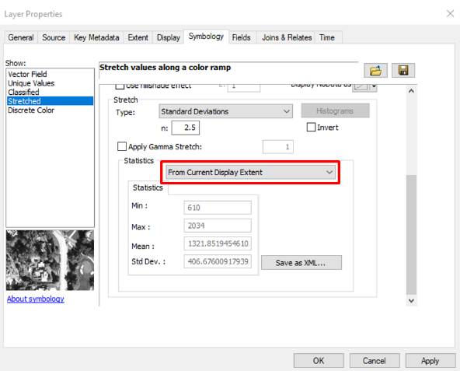

1. Burn Culverts Into DEM

You will use the culvert polygons to change the values of the DEM at the culvert locations to “enforce” the flow. To do so, you will first convert the Polygons to a Raster. Follow the steps below.

* 1. Create (or obtain) a shapefile of all culverts and drainage structures

Use GIS data, road logs, or utility database, etc. to determine culvert locations. If you can, locate a database with the point locations or create polygons of these locations, being as precise with their placement as you can (this may require field time and using a GPS to record the culvert locations).

* 1. Convert culvert to a raster ESRI Grid.
     1. From ArcToolbox, open **Conversion Tools**, **To Raster**, then select **Feature to Raster**
     2. Choose **Culverts.shp** as Input Features
     3. Set ELEV **field** as the value.
     4. Name it **Culv_Ras** (be sure to leave the file extension “blank” so that an ESRI Grid will be created).
     5. Set cell size to **1 meter**, which is the same cell size as the **RiverDEM**.
     6. Leave all other parameters as default.
     7. Click **OK** to run.
  2. Mosaic the two raster datasets to “merge” them together
     1. From ArcToolbox, open **Data Management Tools**, **Raster**, **Raster Dataset**, then select **Mosaic to New Raster.**
     2. Add **Culv_Ras** and **RiverDEM**
     3. Select an intuitive output location and name the new raster dataset **CulvDEM**. Do not add an extension to create an Esri Grid
     4. Set pixel type for dataset to **32 bit Signed.**
     5. Set number of bands to **1**.
     6. Set Mosaic Operator to **First**

IMPORTANT: Mosaic method needs to be set to First to allow the culvert raster to get priority in assigning elevation to new raster cells (e.g. Culv_Ras should be on the top of the table of contents and has the minimum value, so, in this instance, you should choose **FIRST** as the Mosaic operator so the first raster (Culv_Ras) will be used). This operation will set values at culverts to 0.

* + 1. Click **OK** to run.
    2. Once the new raster is created, zoom in to the newly burned in culverts and explore the values at the culvert locations and around it. Your culvert locations should be lower than all the cells around it. We just created sinks! Next we need to fill them. This process just ensured we didn’t have a local maximum at the culvert locations. Now when we model streams the flow will flow through the culverts. The image below on the right is a zoomed in version with a transparency (30%) on the DEM and the NAIP 2010 imagery in the background.

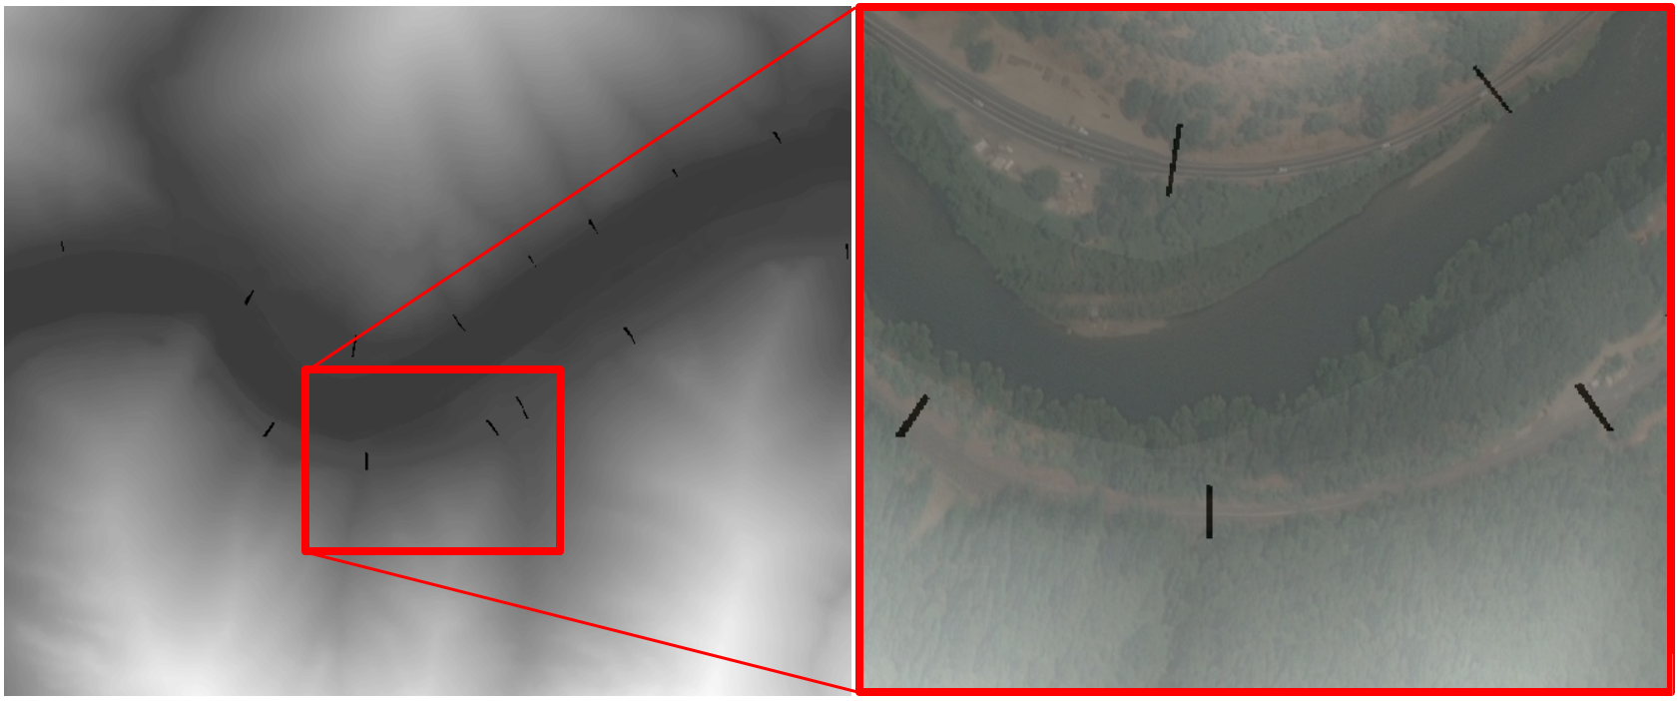

1. Fill Sinks in CulvDEM
   1. Fill Sinks in CulvDEM
      1. From ArcToolbox open, Spatial Analyst Tools, Hydrology, then select **Fill**
      2. Set Input Surface raster as **CulvDem**
      3. Name the output **CulvFill**
      4. Click **Ok** to run the tool
   2. Inspect your Fill raster
      1. View the CulvFill raster and zoom into the location of some of the culverts (e.g. scale of 1:3,000).
      2. Using the **Identify tool** inspect the values in and around the locations of the burned in culverts.

***Note:*** *You should notice the sinks and culvert values have been “raised” to the minimal values of nearby cells to allow for preferred flow through those sinks.* For example, the value at the green arrow in the filled raster is 628, and in the CulvDEM it was 0.

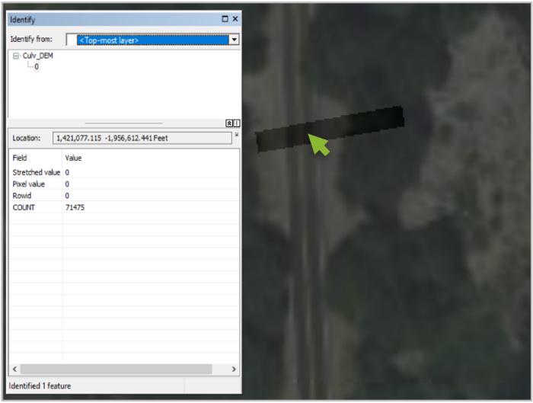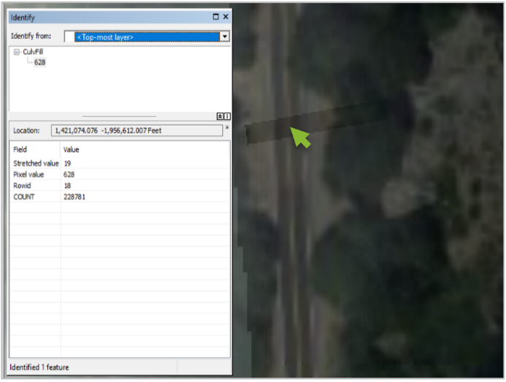

**Note:** If you are working on your own dataset, and don’t have a culvert file, you could first run the stream creation process (see next exercise) and if there are parts of the terrain where the streams are running along the road or aren’t following the true stream location, this may be a location to place a “culvert”. You could create a new shapefile and either digitize a line or points in the location of the needed culvert.

**Congratulations!** You have successfully completed this exercise. You now know how to use some of the fundamental hydrology tools that are necessary for a successful hydro modeling workflow.