Last Updated: March 2020

Version: ArcMap 10.5.x

# EXERCISE 5a

**Create Streams and Subwatersheds**

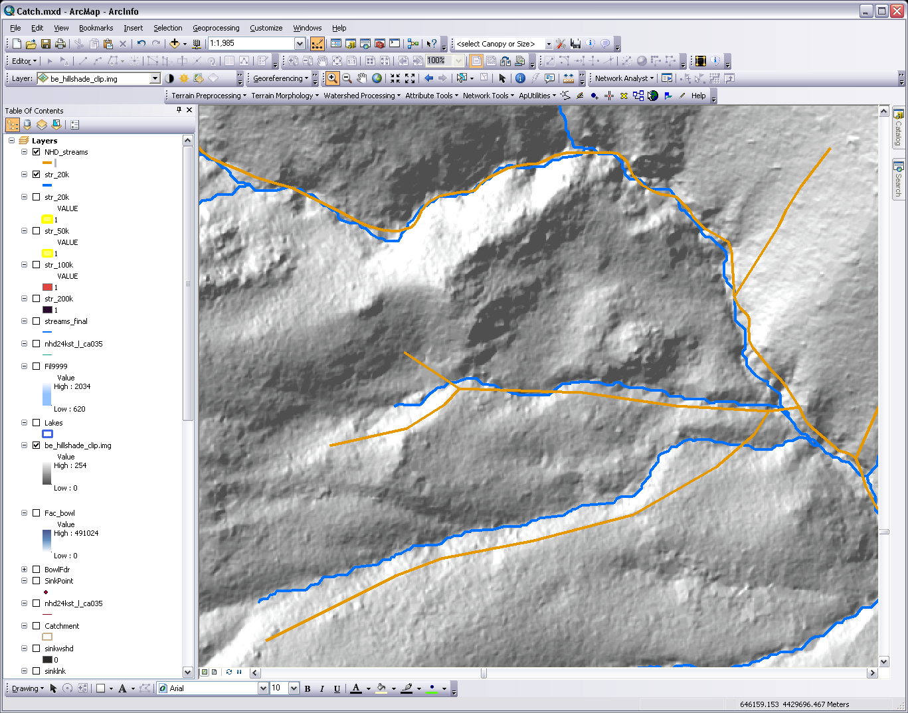

**Introduction**

In this exercise you will use your prepared, hydro-enforced, lidar DEM and the Hydrology tools to generate a new network of streams and subwatersheds. You’ll use a series of tools (Flow Direction and Flow Accumulation) to create your final streamlines.

**Objectives**

* Create final streams layer using processed DEM

**Required Data**

* **CulvFill**—output from exercise 4
* **be_hillshade_clip.img**—output from exercise 3

**Prerequisites**

* Spatial Analyst extension- installed and activated in ArcMap

Table of Contents

Part 1: Create Streams 3

Part 2: Create Subwatersheds and Final Stream Layer 4

1. Create Streams

After hydro-enforcing your lidar-derived DEM by burning culverts and major rivers into the DEM and filling the resulting sinks, you are now ready to generate the rasters that will get you to your final objective.

* 1. Open ArcMap and ArcHydro
     1. In ArcMap, make sure you have the following datasets:
        1. **be_hillshade_clip_int.img**
        2. **CulvFill**
     2. If you have the Image Server activated, please access it and add the following**: NAIP\NAIP2018_CONUS**.
  2. Calculate Flow Direction

The Flow Direction tool uses the D8 flow model, which assumes that water from any given grid cell will flow into one of the eight adjoining cells according to the direction of steepest descent. The resulting flow direction grid contains cells with values defined by one of the eight flow directions.

* + 1. From Arc Toolbox, Spatial Analyst, Hydrology, select the **Flow Direction** tool**.**
    2. Set the Input Surface as **CulvFill**
    3. Name the output Flow Direction raster **Fdr.img**
    4. Leave output drop raster as Null
    5. Click **Ok** to run. This process may take several minutes to run.
  1. Calculate Flow Accumulation Raster

Using the Flow Direction raster as the basis, each cell in an accumulation grid is assigned a value that represents the accumulated number of cells that drain into that individual cell. Knowing which direction the flow goes from each cell allows the flow accumulation process to determine the number of cells that “pour” into any given cell in the flow accumulation raster.

* + 1. From Arc Toolbox, Spatial Analyst Tools, Hydrology select the **Flow Accumulation** tool.
    2. Use **Fdr** raster as the input.
    3. Name the output raster **Fac.img**
    4. Leave the rest of the settings as the default.
    5. Click **OK**
  1. Create Stream Definition Raster

Using the Flow Accumulation raster, the user defines the “number of cells” from upstream flow that contribute to an individual cell’s flow accumulation value. This threshold defines streams and can be defined so that only large, primary streams are captured, or so that smaller, more ephemeral streams are also included.

* + 1. From Arc Toolbox, Spatial Analyst, Map Algebra open the **Raster Calculator**
    2. In the expression box Enter Con( “fac.img” > 200000, 1) This expression sets cells with over 200,000 cells flowing into them to a value of 1 and all others to NoData to create a stream raster. For the number of cells, use your best judgment. We recommend 1% of the overall area. If this does not produce a detailed enough stream network, then use a lower number of cells to initiate a stream. We will use **200,000.**
    3. Name output raster appropriately, e.g. **Str200k** (indicates that 200,000 cells were used as the threshold).

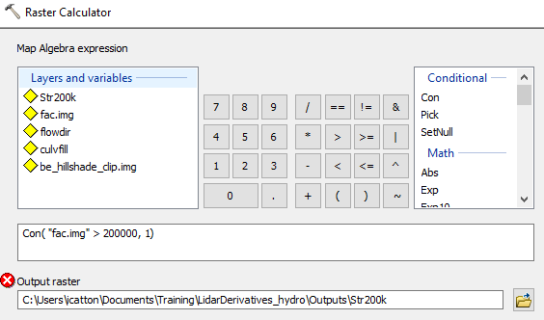

* + 1. Click **Ok**  to run.
    2. View your output. The resulting raster has a value of 1 where the flow condition is met.

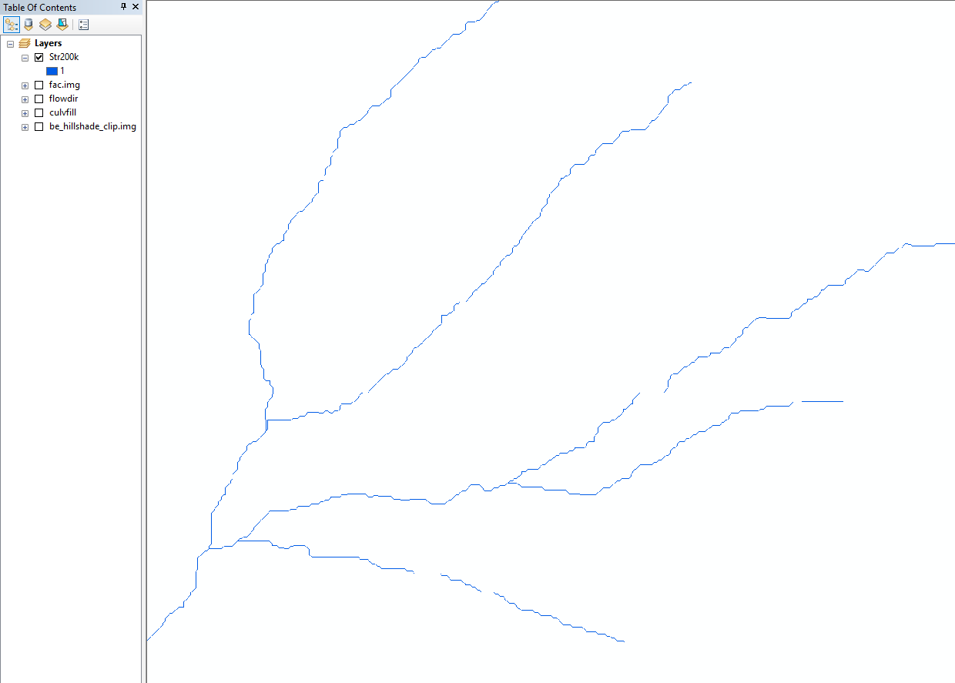

1. Create Subwatersheds and Final Stream Layer

You can create subwatersheds from the Flow Direction grid by creating additional layers that will further define smaller watersheds than what you can obtain from the National Hydrography Dataset. Additionally, in this part you will create your final vectorized stream layer.

* 1. Stream Segmentation-in preparation for subwatershed creation
     1. In this step, the function creates a raster of stream segments that have a unique ID. The ID defines what part of the stream the segment belongs to—e.g. a head segment or a between segment. All the cells in a particular segment have the same grid code. The output from this is used in creating the Watershed grid.
     2. From **Arc Toolbox, Spatial Analyst, Hydrology**, Open the **Stream Link** tool.
     3. Use your **Str200k** raster as Input Stream raster.
     4. Use the **Fdr** raster as the Input Flow Direction raster.
     5. Leave the two optional inputs (Sink Watershed and Link Grids) as **Null.**
     6. Name the Output **StrLnk**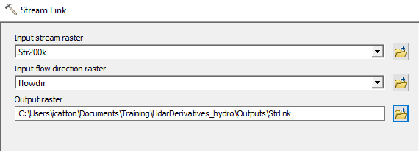

**Note:** This output looks similar to the Stream Definitionoutput but it has a different value for each stream segment.

* 1. Watershed Delineation

This function uses the Stream Link output to create a grid in which each cell carries a value (grid code) that indicates which watershed the cell belongs to. This is achieved by determining the value carried by the stream segment grid that drains that area and applying it to the watershed grid.

* + 1. From Arc Toolbox, Spatial Analyst, Hydrology and open the **Watershed** tool.
    2. Set Flow Direction Grid to **Fdr.**
    3. Set Input raster to **StrLnk.**
    4. Name the Output **WtrShd.** This tool may take over 20 minutes to complete. You can try to process smaller chunks of your raster or use the output layer WtrShd in CourseDownloads/outputs. (see output below)

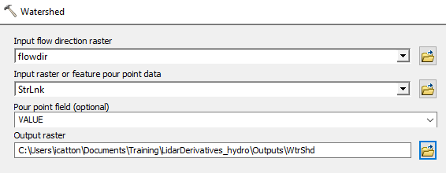

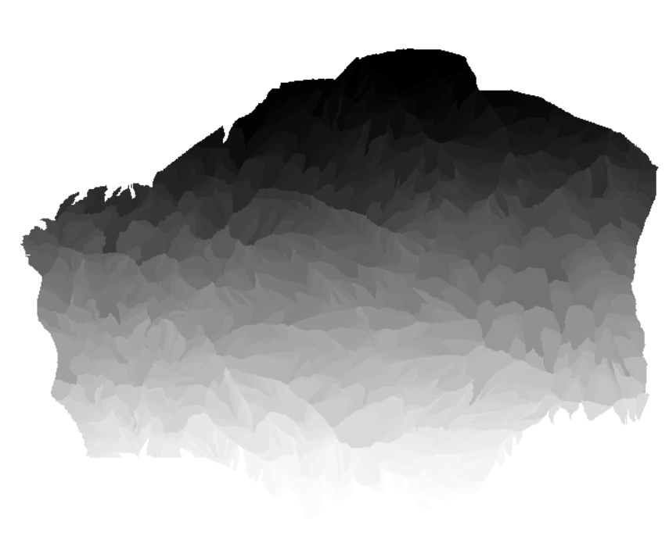

* 1. Stream Creation (aka FINAL Stream Layer)

In this step, we are creating our “final” stream layer. Doing it during this subwatershed process means that it will take on some attributes from our previous steps, such as the watershed ID from which it resides.

* + 1. From Arc Toolbox, Spatial Analyst, Hydrology, open the **Stream to Feature** tool.
    2. Set Input Stream Raster to **StrLnk**
    3. Set the Flow Direction Grid to your **Fdr** raster.
    4. Name the Output **StreamFeature.**

**Note:** In the following graphic, the hillshade is displayed behind the StreamFeature.shp.

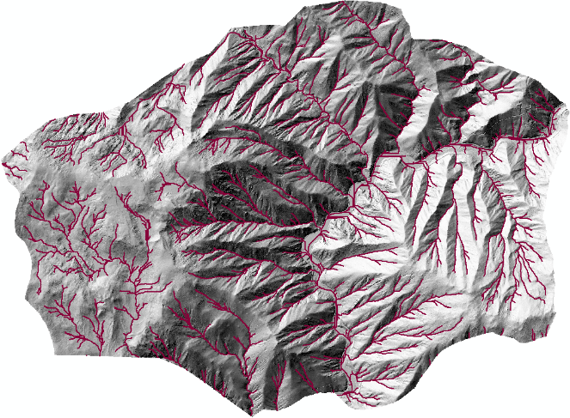

* 1. Inspect Output
     1. Click the **Add Data** button, navigate to the Hydro Data folder and add **NHD_streams.shp**. We will compare our new stream network to this one to see if we achieved a more spatially accurate dataset. Zoom into the location of some of the culverts (e.g. scale of 1:3,000).
     2. With the newly created **DrainageLine.shp** turned on, use the Zoom and Pan tools to inspect your finalized stream layer. For additional visualization purposes, turn on the **Hillshade** raster underneath the stream layer.

NOTE: In the following figure the NHD streams are in orange and the new lidar-derived streams are in blue.

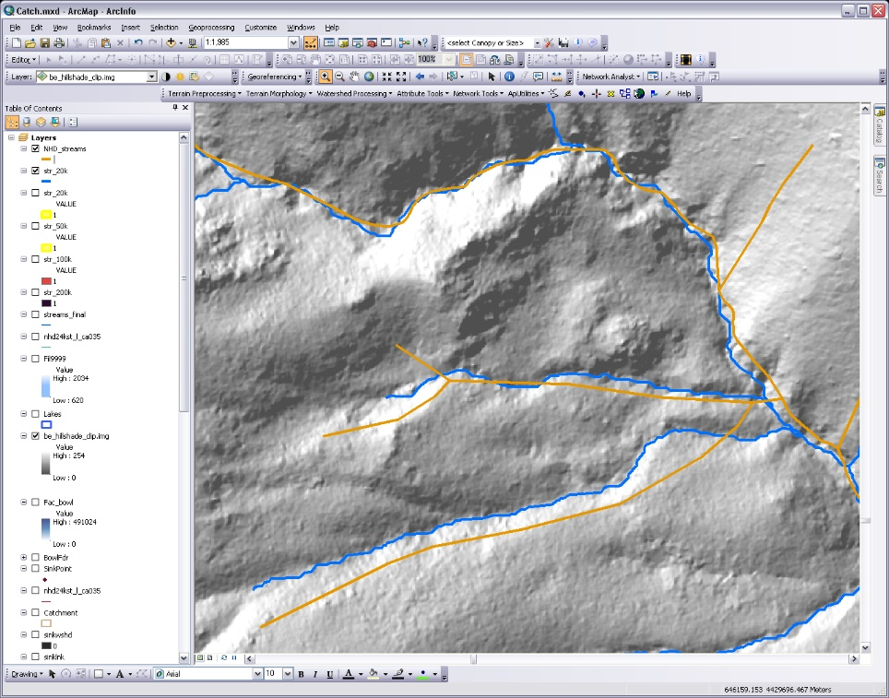

**Congratulations!** You have successfully completed this exercise. You now know how to create stream flowlines from a lidar derived DEM.