Last Updated: January 2021

Version: ArcMap 10.x

# EXERCISE 1b

# Habitat Suitability

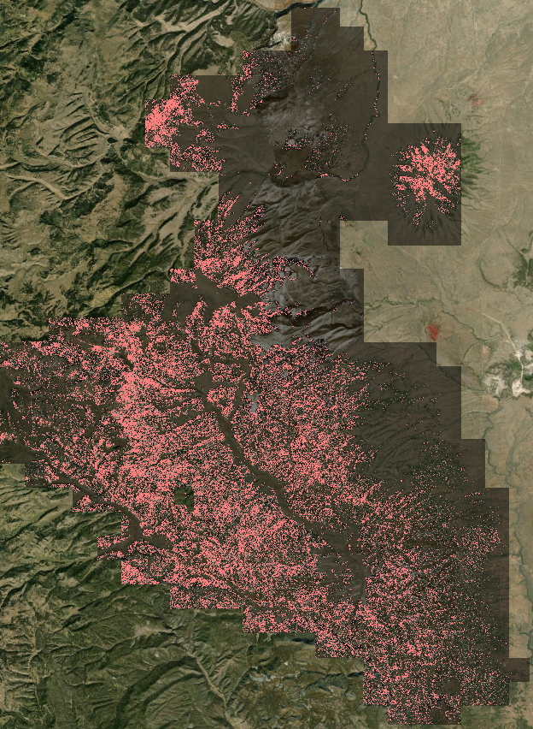

Introduction

This exercise will take you through the basics of using the raster calculator tool in ArcMap to create a simple habitat suitability map. Using conditional statements, you will use the lidar derivatives representing canopy height and canopy cover to model the habitat of a fictional “endangered bird species”. In future applications, you can use a variety of lidar derived variables such as the ones derived from the GridMetrics command in Fusion or other surface layers (e.g., aspect and slope), but for this exercise we will simply use the ones that many regions provide for you. Again, you will be using data from the Carson National Forest in New Mexico.

Objectives

* Use conditional statements in the raster calculator to identify suitable habitats

Required Data

* **RioTusas_DEM.img -** Digital elevation model derived from the last returns of the lidar point cloud
* **RioTusas_CanopyCover_10m.img -** Percentage of canopy cover derived from the lidar point cloud
* **RioTusas_CHM_1m.img –** Canopy height layer derived from the 95 percentile of returns of the lidar point cloud (p95 is used to reduce the number of error pixels derived from incorrect height lidar values)

Prerequisites

* It is recommended that you are somewhat proficient using ArcMap.

Table of Contents

Part 1: Set up ArcMap 4

Part 2: Simple Conditional Statements 4

Part 3: Complex Conditional Statements 6

Part 4: Analyze the Habitat Suitability Output 7

1. Set up ArcMap
   1. Start ArcMap
      1. If it is not already open start ArcMap by clicking on the Start button and navigating to **All Programs, ArcGIS** and then open **ArcMap.**
      2. Open a blank map.
   2. Add The DEM, Canopy Cover And Canopy Height Rasters
      1. Click the **Add Data** button (see following graphic).

Add data button in ArcMap


* + 1. Navigate to ... **ProjectData\DEM** and add **RioTusas_DEM.img**
    2. Navigate to ... **ProjectData\Lidar** and add **RioTusasa_CanopyCover_10m.img** and **RioTusas_CHM_1m.img** from their respective subfolders.
    3. If you want a reference image, add some imagery, either the NAIP image from your NAIP folder or use the image server.
    4. Order your images in the **Table of Contents** so that the **CHM** layer is on top, then **Canopy Cover, DEM**, and any Imagery you added (e.g. **NAIP**).
  1. Activate Spatial Analyst Extension And Open ArcToolbox
     1. If you haven’t already, activate the **Spatial Analyst** extension. From the **Customize** menu, choose **Extensions**.
     2. In the **Extensions** dialog, put a checkmark next to **Spatial Analyst**. This makes that extension available to use.
     3. Click **Close** to dismiss the **Extensions** window.
     4. If the ArcToolbox window is not visible, click the ArcToolbox button (see graphic below). You can dock the window next to your Table of Contents.

ArcToolbox button in ArcMap

1. Simple Conditional Statements
   1. Calculating Canopy Height
      1. From the **Spatial Analyst** toolset in **ArcToolbox,** navigate to **Spatial Analyst**, **Map Algebra**, and then open **Raster Calculator**.
      2. Enter **Con("RioTusas_CHM_1m.img" > 5,1,0)** by typing it exactly as you see here, or double click **“Con”** in the upper right portion of the raster calculator window and double click the canopy height raster in the list of available Layers and Variables.

**Note:** In reality, the above statement is not any different than a simple query of the CanopyHeight raster. The output will have a 1 where the condition (where the CanopyHeight raster is greater than 5) is true and a 0 where it is false. If you don’t enter a False value (e.g 0), the default false output will be NoData. This is an easy way to set unwanted data values to NoData. A query function would return the same result. Name the Output raster **HeightAbove5.img** and put it in the **Outputs** folder (see following graphic).

* + 1. Select a location for the raster output in the Output raster box and name the raster **HeightAbove5.img**.

Raster calculator box showing a condtional statement to calculate canopy height above 5 feet


* + 1. Click **OK** to run the process.
  1. Inspect The Results
     1. Use the **Zoom** and **Pan** tools (see following graphics) to inspect the results.

zoom toolpan tool

* + - 1. You should notice that areas that had a **CanopyHeight > 5** are colored similar to the figure below. This process can be used to analyze and manipulate your data in specific ways that may help with your analysis.

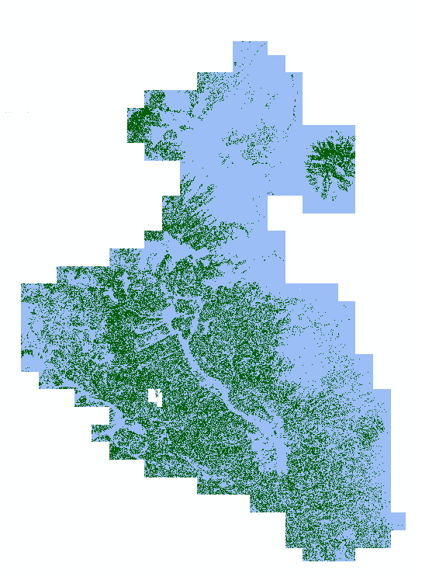

1. Complex Conditional Statements

**Note:** You have just executed a relatively simple conditional statement and reviewed the results. In the next section we will explore more complex and powerful expressions, such as running multiple conditional statements in one expression. The added complexity will pay off with an increase in efficiency for our geospatial workflow.

* 1. Write A More Complex Statement
     1. Open the **Raster Calculator** tool, just as you did in the previous section.
     2. Enter this in the Raster Calculator window, **Con(("RioTusas_CHM_1m.img" > 5) & ("RioTusas_CanopyCover_10m.img" > 50),1,0)**
        1. Let’s analyze the above statement to see what is going on. This process will create a raster where cells that have a Height > 5 and a Cover > 50 will have a value of 1, and everything else will have a value of 0. In other words, every pixel or location between the two rasters (Canopy Height and Canopy Cover) where the specific conditions are met will get classified as 1’s.
     3. Give a name to the output raster such as **Height5_Cover50.img** and put it in the **Outputs** folder.
     4. Click **OK** to run the process.
  2. Write an Even More Complex Statement
     1. Imagine that we have determined that our fictional “endangered bird species’” ideal habitat occurs in trees between 5 and 25 feet and in areas where the canopy Cover is greater than 50.
     2. Try to write a conditional statement that captures this habitat scenario: has a height > 5 but < 25 and has a canopy Cover of > 50.
     3. It should be similar to this, **Con(("RioTusas_CHM_1m.img" > 5) & ("RioTusas_CHM_1m.img" < 25) & ("RioTusas_CanopyCover_10m.img" > 50),1,0)**
     4. Name your output **HabitatSuitability.img** and save it to the same location. Run the process, it should look similar to the following graphic (it may be different colors).

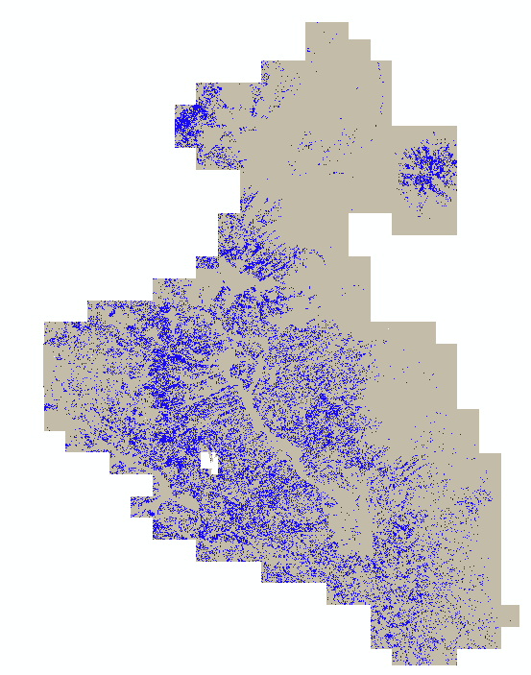

1. Analyze the Habitat Suitability Output
   1. Make The Habitat Suitability Layer Transparent
      1. Double Click the **RioTusas_CHM_1m.img** layer to open the layer properties.
      2. Click the **Display Tab**.
      3. In the transparency box, set the **Transparency** value to 50.
      4. Click **Ok.**
   2. View The Habitat Suitability Layer On Top Of Canopy Height Layer
      1. Make sure that your **Habitat Suitability** layer is above your **Canopy Height** layer by reordering them in the Table of Contents by dragging and dropping.
      2. Change the color of the **0** pixels so that they have no color and change the **1 pixels** to a color that is noticeable (Red).
         1. Do this by double clicking the color box next to 0 below the layer in the **Table of Contents.**
         2. Click the **Fill Color:** dropdown.
         3. Click **No Color** then click **OK**.
         4. Double click the color box next to 1 below the HabitatSuitability layer**.**
         5. Click the **Fill Color:** dropdown.
         6. Click a **red** color, then click **OK**.



**Note:** More complex raster calculator math can be performed and there are other tools (such as the weighted sum tool) that make it possible to do more complex suitability analysis. For the purpose of this exercise we wanted to provide you with a fundamental understanding of how to perform some basic raster calculator functions. You can expand on these in the future.

* + 1. Zoom in and explore the areas where there is suitable habitat.
       1. The spatial resolution of the layers used for the analysis create a salt and pepper effect, but general patterns can be observed regarding where bird habitat needs to be preserved (see figure on the following page).
    2. What things can you now do with this layer? You can find stands that may need more management to make sure there is enough habitat for this species, or identify areas that aren’t currently occupied by the species but that could be used as habitat by them.

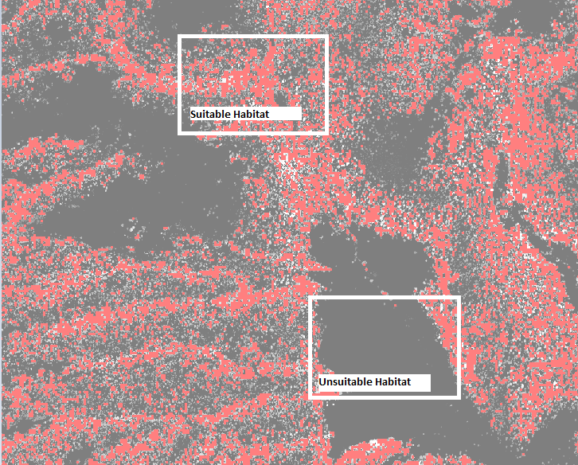

**Congratulations!** You have successfully completed this exercise. You now know how to integrate multiple derivatives into a habitat suitability analysis. You can use the skills you leaned in this exercise to extract a variety of different forest and surface characteristics from rasters.