Last Updated: September 2019

Version: ArcMap 10.x

# EXERCISE 2b

# Forest Stratification

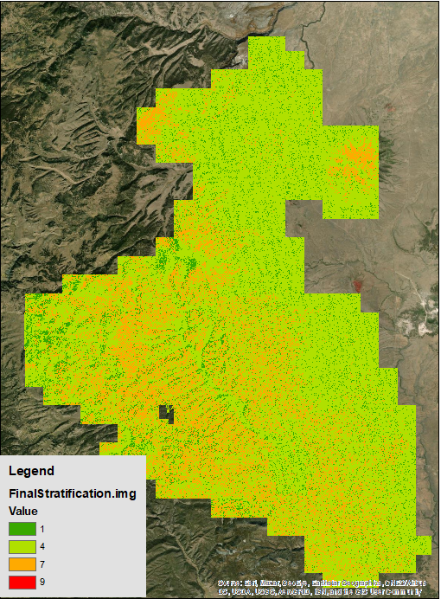

Introduction

This exercise will focus on using the skills you have acquired in previous exercises and build upon them to stratify the forest into different classes using the lidar-derived canopy height and canopy cover layers. This is something you may do when trying to delineate stands or when creating a sampling scheme based on lidar sampled cover and height. If your Forest already has these two basic lidar derivatives, you can use this workflow to create stratifications where you can then randomly place field plots. This ensures that you are more likely to sample the full range of possible vegetation characteristics within the study area.

The first portion of this exercise will introduce you to the reclassify tool, which enables you to stratify a continuous raster into user-defined height classes. The second portion of the exercise focuses on using the raster calculator to stratify the study area using both the canopy height and the canopy cover rasters. As with other exercises, the concepts here are the rudimentary beginnings, and you will want to apply your own knowledge of your forest and expand these techniques to get an appropriate and useful product in the future.

Objectives

* Use the raster calculator to create a raster that separates the study area based on specific canopy height and cover characteristics.

Required Data

* **RioTusas_CHM_10m.img –** Tree height in feet, horizontal resolution is in meters. This data is usually a higher spatial resolution, but it has been generated at a 10m spatial resolution in order to match the canopy cover layer.
* **RioTusas_CanopyCover_10m.img –** Canopy cover expressed as a percentage

Prerequisites

* **Install ESRI ArcMap on computer** and have basic understanding of how to use the software

Table of Contents

Part 1: Set up ArcMap 4

Part 2: Determine the Stratification Values and Reclassify the Canopy Height Raster 4

Part 3: Stratify the Forest Using Raster Calculator 7

1. Set up ArcMap
   1. Start ArcMap
      1. If it is not already open start ArcMap by clicking on the Start button and navigating to **All Programs, ArcGIS** and then open ArcMap**.**
      2. Open a blank map.
   2. Add The Data
      1. Click the **Add Data** button.
      2. Navigate to \**ProjectData\Lidar\** and add **RioTusas_CHM_10m.img** and **RioTusas_CanopyCover_10m.img**

**Note:** We are going to use a larger spatial resolution (10 meters) canopy height layer to reduce noise in the data and so that it is the same resolution as the canopy closure model. Often times we do not necessarily need the data to be at such a high spatial resolution if we are looking for larger trends on the landscape. In this case we are trying to stratify the forest by height and closure and detect stands of trees with a unique structural signature therefore we can afford to resample the data to lower spatial resolution and in reality the finer spatial scale is not needed and creates noise.

This data we will use is the smaller subset that we used during our first Fusion exercises. We are using this data because it was created at a 10 meter resolution from the LTK processor. It is almost always better to create the product with the resolution you want directly from the Lidar data instead of resampling the data afterward. In order to do this you will need to ask your regional coordinator for that specific data or derive it yourself using FUSION.

1. Determine the Stratification Values and Reclassify the Canopy Height Raster

In this section, you will focus on changing the canopy height raster symbology from “stretched” to “classified,” which enables you to split the data into different categories using a few different methods. The goal is to split the height data into three categories (short, medium and tall) using information from the histogram to ensure that the height data is split evenly between the 3 categories. Once you split the data into those categories in the Layer Properties, you will then use the Reclassify tool to essentially cement those categories so that you can easily do some raster math later in the exercise.

* 1. Change Symbology And Classification Of The Height Layer
     1. Double click on the **10mCanopyHeight_LidarDerived.img** in the Table of Contents to open the layer properties.
     2. Click on the **Symbology** tab and change the symbology type to **Classified** (Left side of the window).
     3. Click on the **Classify** button.
     4. Change the number of **Classes** to **5.**
     5. The default method is **Natural Breaks.** We will change this and manually set our break values.
     6. You will want to experiment with the break values, so go ahead and do so and see what happens to the raster when you change the **Break Values.**
        1. Explore changing some of the other methods of classification and see the difference. Try Standard Deviations, Equal Intervals, etc…

**Note:** for more information on these data classification methods, refer to ESRI’s help information: <https://pro.arcgis.com/en/pro-app/help/mapping/layer-properties/data-classification-methods.htm>.

* + 1. Choose **Quantile** as the Method in the Classification window.
       1. Quantile separates the data equally among the user-defined number of classes.
    2. Choose **3** as the number of classes.

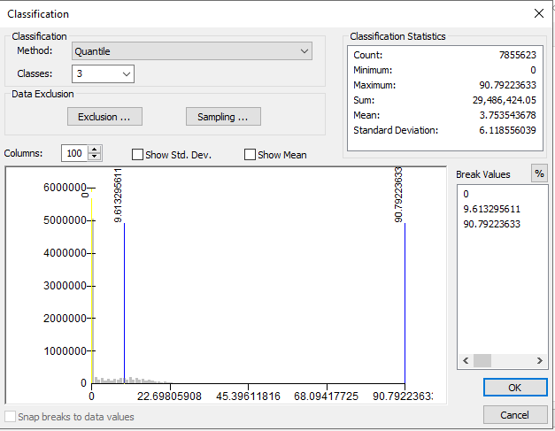

* + 1. Click **OK** and then **OK** again to close your Layer Properties window. Your raster should now resemble the following figure.

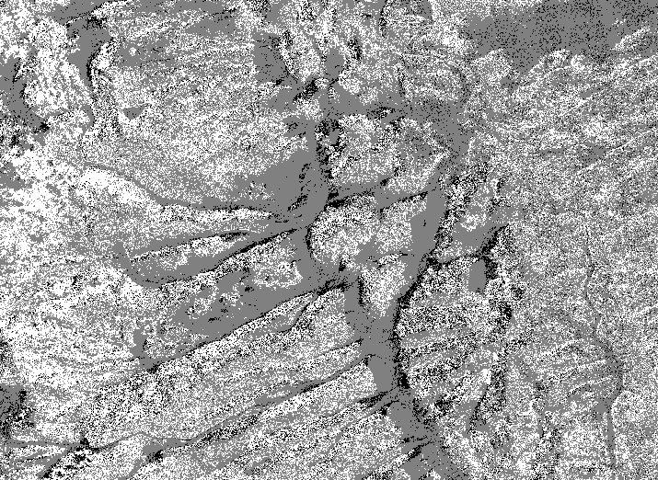

* 1. Reclassify the Canopy Height Raster

The previous section showed you how to classify the height into 3 different categories via the Layer Properties window. However, you can do the same thing in the Reclassify tool, if so desired. The main difference is that the reclassify tool doesn’t *just* change the symbology. Instead, the reclassify tool takes those categories and reclassifies them as a new value. In this case, those categories will be relabeled as 1, 2 and 3.

* + 1. From the ArcToolbox navigate to **Spatial Analyst Tools, Reclass, Reclassify**
    2. Use the **RioTusas_CHM_10m.img** as your input raster.
       1. The **Reclassification** window with values you have already set in the symbology should automatically be populated with those values. If you need to change them or redo them you can click the **Classify** button and follow the previous steps.

**Note:** We are going to leave the **NoData** values as NoData but be aware that there are a few values within the raster that are NoData pixels. These values were outside of the range we used when creating this raster layer so most likely that means there is no vegetation there. When we compose the final Stratification model these areas will also be output as NoData. In the future you may want to reclassify those values but for this exercise we will leave them as NoData.

* + 1. For the output raster navigate to the **Outputs** folder and name your raster **Height10m_Reclass.img**
    2. Click **OK** to run the process.
    3. Your output should look similar to the figure below. The colors will vary.

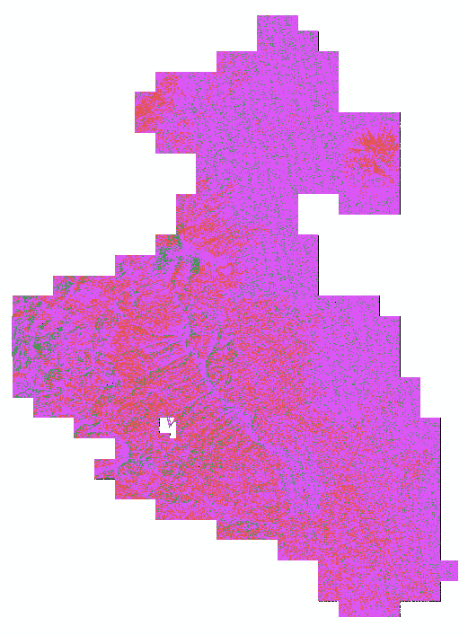

**Note:** This was an example of how to reclassify one raster. If you are only interested in the heights of trees for your specific application, then this is a good way to break up your data for analysis. However, we will typically use more information to stratify the forest. In the next section, we will describe how to combine the canopy cover and height raters into one classification scheme using the Raster Calculator. The reclassified height breaks you created in this section will be applied to that classification.

1. Stratify the Forest Using Raster Calculator

Now that we have determined the height classes, we will combine those classes with three canopy cover classes: 0-33%, 33-66%, 66-100%. Ultimately, you will create 9 different strata using the 3 categories from each raster dataset. To do this we use a nested conditional statement. We cannot use the Reclassify tool because we are using two different raster layers as input. To make the conditional statements more manageable, you will break them into 3 different raster calculator expressions. You could, however, combine the conditional statements into one long statement, but that makes troubleshooting syntax errors more difficult.

* 1. Use Nested Conditional Statement to Create the First Stratification Layer
     1. The nine stratifications can be seen in the table below. Again we will make 3 different conditional statements to do this. Notice that the height breaks are the same thresholds identified in the previous section.
        1. Note that we are going to use the reclassified height data, which now has those height ranges split up into classes 1, 2 and 3.

| **Stratification** | **Height Condition** | **Cover Condition** |
| --- | --- | --- |
| 1 | >3 & <= 80 feet | <= 33% |
| 2 | >3 & <= 80 feet | > 33 & <= 66 % |
| 3 | >3 & <= 80 feet | > 66 & <= 100 % |
| 4 | >80 & <= 103 feet | <= 33% |
| 5 | >80 & <= 103 feet | > 33 & <= 66 % |
| 6 | >80 & <= 103 feet | > 66 & <= 100 % |
| 7 | >103 & <= 196 feet | <= 33% |
| 8 | >103 & <= 196 feet | > 33 & <= 66 % |
| 9 | >103 & <= 196 feet | > 66 & <= 100 % |

**Note:** refer back to this table once you have created your final raster. You can use this to rename your classes from 1-9 to more intuitive classes (e.g., short & low cover; medium & low cover; high & low cover, etc.).

* + 1. To make our statements more manageable lets first change the name of our layers in the **Table of Contents.** 
       1. Click the Layer to highlight it in blue.
       2. Click the layer again so you can change the layer title.
       3. Change **10mCanopyHeight_LidarDerived** to **Cover.**
       4. Change **Height10m_Reclass** to **Height** (see below).

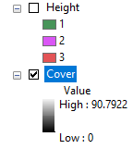

* + 1. Open the **Raster Calculator** tool.
    2. Enter the following statement using the **Height and Cover** layers. Make sure you get the syntax completely right or it won’t work or will produce erroneous results.
       1. **Con(("Height" == 1) & ("Cover" <= 33),1,Con(("Height" == 1) & ("Cover" > 33) & ("Cover" <= 66),2, Con(("Height" == 1 ) & ("Cover" > 66) & ("Cover" <= 100),3,0)))**
          1. Ensure that you select the symbols and layer names from the Raster Calculator window.

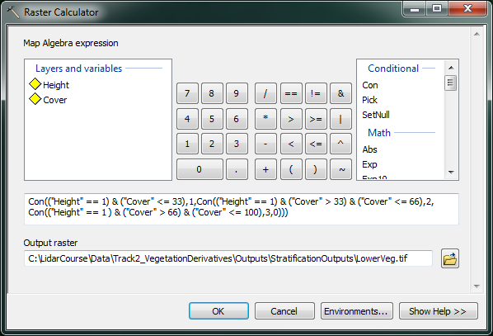

* + 1. This nested statement basically makes use of multiple conditional statements. If the first condition isn’t met, then it iterates to a new conditional statement. In the final statement, the false output will be a 0. Once we have three outputs we will add them together and anywhere with a 0 will fit none of the conditions (e.g. vegetation < 3 feet).
    2. Call the output **LowerVeg.img** and save it in the **Outputs** folder**.**
    3. Click **OK** to run the tool.
  1. Use Raster Calculator To Create The Final Two Stratification Groups

Now we need to create the other 6 stratification classes using two separate conditional statements

* + 1. Open **Raster Calculator** and enter the following statement:

**Con(("Height" == 2) & ("Cover" <= 33),4,Con(("Height" == 2) & ("Cover" > 33) & ("Cover" <= 66),5, Con(("Height" == 2 ) & ("Cover" > 66) & ("Cover" <= 100),6,0)))**

* + 1. Call the output **MiddleVeg.img** and save it in the **Outputs folder.**

**Note:** Notice how similar this statement is to the previous one. We are just changing the height parameters so that we are getting three different height classes. We are naming them 4, 5 and 6 so that when we add them all up in the end we will have one raster with 9 different classes.

* + 1. Open **Raster Calculator** again and enter the following:

**Con(("Height" == 3) & ("Cover" <= 33),7,Con(("Height" == 3) & ("Cover" > 33) & ("Cover" <= 66),8, Con(("Height" == 3 ) & ("Cover" > 66) & ("Cover" <= 100),9,0)))**

* + 1. Name the output **HighVeg.img** and put it in the **Outputs** folder.
    2. In your table of contents, you should see the LowerVeg, MiddleVeg, and HighVeg layers.
  1. Use Raster Calculator To Create Final Stratification Layer

We now need to add all of the rasters together, but we still may have some areas that don’t fit any of the criteria. These areas should be set to Null (i.e., NoData). We can do this all in one statement using the **SetNull** statement in **Raster Calculator.**

**Note:** The SetNull function will take any condition and set pixels that fulfill that condition to null. It is basically the opposite of the con statement. The false section of the statement can be set to anything. So in this case we will tell it to look for any pixel that is zero in all three stratification rasters and set that to null. Everywhere else we will add the rasters together to create one raster.

* + 1. Open the **RasterCalculator** tool and enter the following:

**SetNull(("LowerVeg.img" == 0) & ("MiddleVeg.img" == 0) & ("HighVeg.img" == 0),"LowerVeg.img"+"MiddleVeg.img"+"HighVeg.img")**

* + 1. This will set any pixel to **Null** that are zeros in each of the three rasters, and will add the other pixels together to create one final raster that contains all 9 stratifications.
    2. Name the output **FinalStratification.img**. It should look like the figure below (it may have different colors).
    3. Click **OK** to run the tool. When it is done processing, open the Layer Properties and select an intuitive Color Scheme. Your output should look similar to the below image.

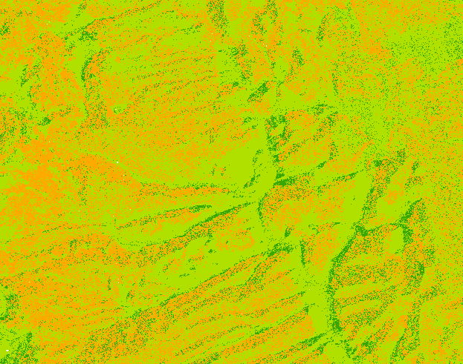

**Congratulations!** You have completed the Forest Stratification exercise. You should now have a rudimentary knowledge of how to use the raster calculator and reclassify tools to stratify a forest. You can always make more complex classifications that are more knowledge based or field based, and integrate additional variables such as species.