< EXERCISE X

Insert Exercise Name Here >

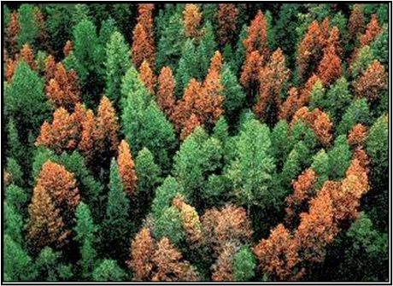
Introduction
Valuable information can be obtained from aerial and satellite imagery. A common method for collecting information from imagery is to manually trace discrete features seen in the imagery by using GIS software and computer input devices (e.g., system mouse, interactive pen display, drawing tablet). While mapping features, it is important to remember the seven characteristics of image interpretation (i.e., tone/color, shape, size, association, shadow, pattern, and texture) and how they relate to the features being mapped. In this exercise, we will be using ArcMap and imagery from the National Agriculture Imagery Program (NAIP) to heads-up digitize damaged stands of trees in the Fishlake National Forest, which is located in central Utah.
Objectives
- List out
- What you want
- People to learn
Required Data:
- Dataset.shp – shapefile representing X to do Y and Z
Prerequisites
- Install X software and have basic understanding of how to use the software.
- Whatever else people need to have / know. Feel free to expand on why they need to know it or where they can find more info.

USDA Non-Discrimination Statement
In accordance with Federal civil rights law and U.S. Department of Agriculture (USDA) civil rights regulations and policies, the USDA, its Agencies, offices, and employees, and institutions participating in or administering USDA programs are prohibited from discriminating based on race, color, national origin, religion, sex, gender identity (including gender expression), sexual orientation, disability, age, marital status, family/parental status, income derived from a public assistance program, political beliefs, or reprisal or retaliation for prior civil rights activity, in any program or activity conducted or funded by USDA (not all bases apply to all programs). Remedies and complaint filing deadlines vary by program or incident.
Persons with disabilities who require alternative means of communication for program information (e.g., Braille, large print, audiotape, American Sign Language, etc.) should contact the responsible Agency or USDA's TARGET Center at (202) 720-2600 (voice and TTY) or contact USDA through the Federal Relay Service at (800) 877-8339. Additionally, program information may be made available in languages other than English.
To file a program discrimination complaint, complete the USDA Program Discrimination Complaint Form, AD-3027, found online at How to File a Program Discrimination Complaint and at any USDA office or write a letter addressed to USDA and provide in the letter all of the information requested in the form. To request a copy of the complaint form, call (866) 632-9992. Submit your completed form or letter to USDA by: (1) mail: U.S. Department of Agriculture, Office of the Assistant Secretary for Civil Rights, 1400 Independence Avenue, SW, Washington, D.C. 20250-9410; (2) fax: (202) 690-7442; or (3) email: program.intake@usda.gov.
USDA is an equal opportunity provider, employer, and lender.
Table of Contents
Part 1: Set up ArcMap 4
Part 2: Study Area 4
Part 3: Methods 4
Part 4: Results/Discussion 4
Part 5: Conclusion 4
Part 6: References 5

- Set up ArcMap
This project is where you can optionally describe what will be covered in Part 1.
  - Open ArcMap
    - Click on the Start Menu,
  - Load the AOI
    - Step 1
    - Step 2
    - Step 3
    - Click the Start Menu, select open the ArcGIS folder, and then click on ArcMap 10.7.1 to launch the software.
Note: If you are not connected to the Forest Service network and are using the Utah_NAIP_2011.tif instead, click the Add Data button and navigate to where you downloaded the exercise material. After you add the reference image to ArcMap, move forward to step 5.

Step 5
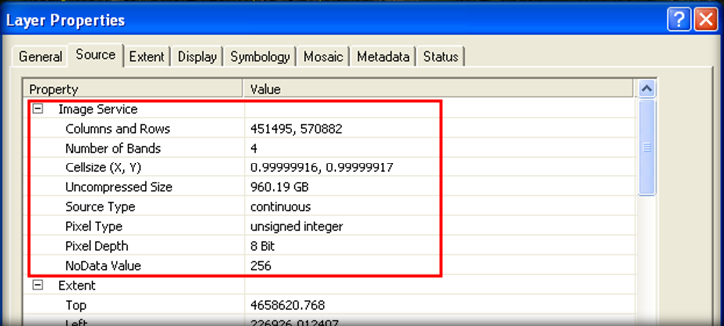
- Do something
  - Create a new shapefile
    - Open the ArcToolbox (see following figure).
Note: It is important that the projection information (especially the datum) is the same for the reference image and shapefile. To learn more about datums, visit NOAA’s datums tutorial.
  - Do something else
    - Click a thing and run a process
- Save your work
  - Wrap up for the day
    - Save
    - Close
    - Go home
Congratulations! You have successfully completed this exercise. You now know the very basics of heads-up digitizing within ArcMap. Hopefully you also had a chance to build upon your image interpretation skills. If you want to learn more about editing features, refer to Appendix A and the ArcMap help documentation.

