These instructions cover submitting IR requests through the NIROPS website and IR Online Ordering webpage only. You still need to place a request in iROC to generate an “A” number for each flight.
Go to https://fsapps.nwcg.gov/nirops/users/login
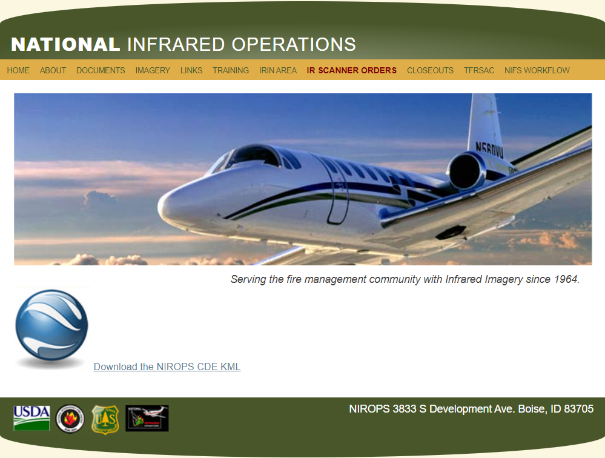
Click on “IR Scanner Orders”
If you do not have an account, click on “Sign up for an account” and follow the directions.
If you have forgotten your password, click on “Forgot username/password” and follow the directions.

NOTE: The following email domains will automatically generate a user account: usda.gov, nps.gov, bia.gov, blm.gov, fws.gov, fire.ca.gov, oregon.gov, dnr.wa.gov, firenet.gov.
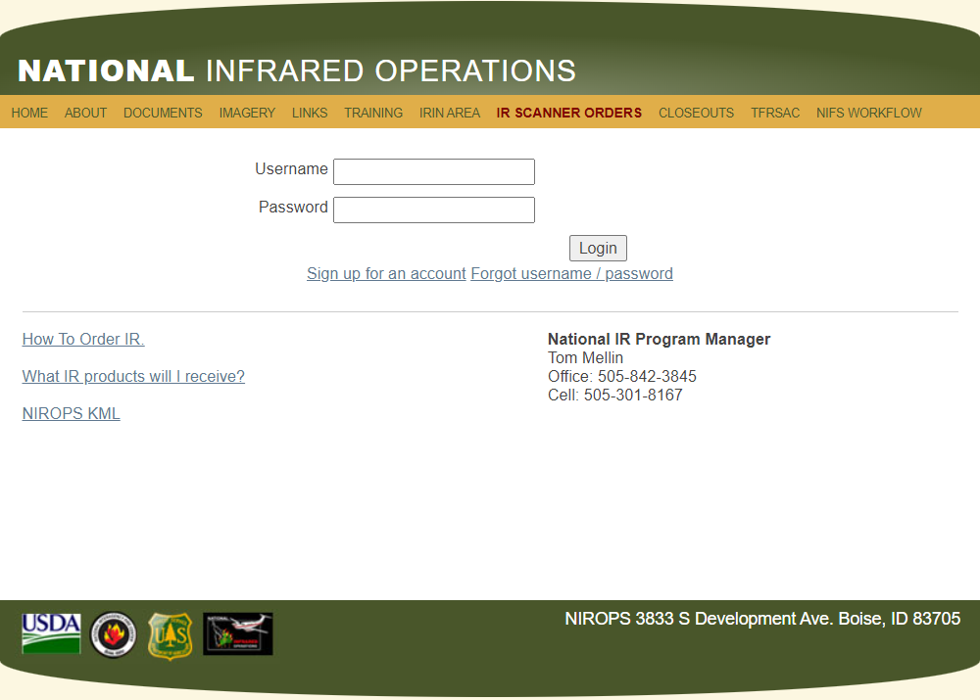

This document

This Document

Click on “Login”. The “Current Orders” page will display.
If there is a previous IR order for the fire, click on “create new order”. Modify the order as needed and click on “Submit as new flight request” at the bottom of the order form.
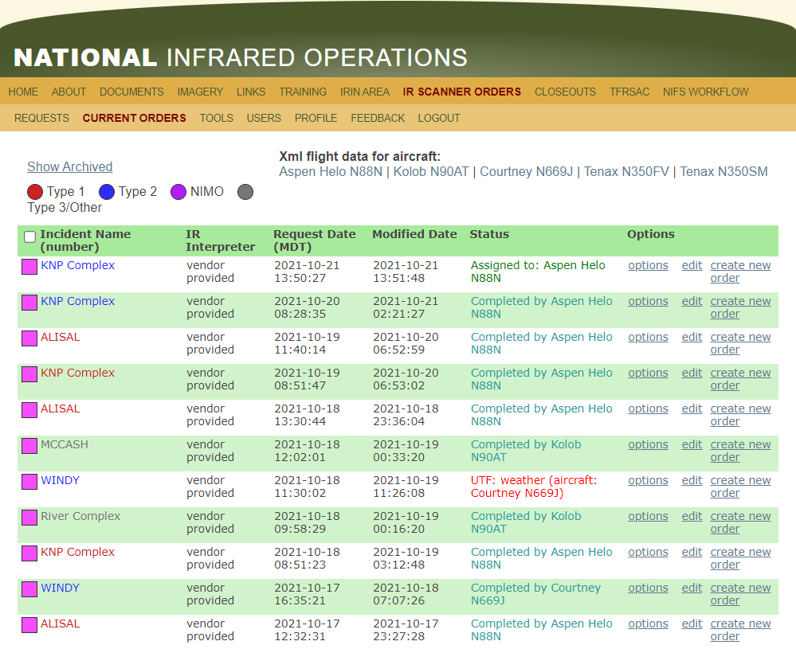
Click on “create new order” if there is a previous IR order for the fire.

If there is no previous order for the fire, click on “Requests”.
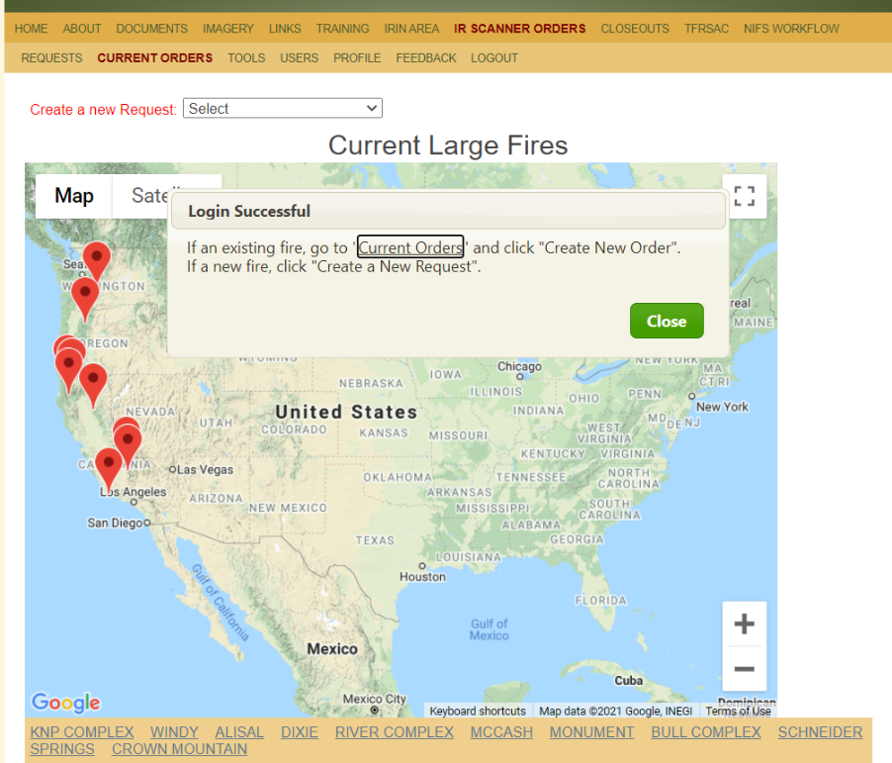
Go to “Create a new Request”
Use the drop-down menu and select from the list of fires OR, click on the marker in the map OR click on the hyperlink at the bottom of the map, OR select Blank Request.
Fires in the list are from the NICC ICS-209 database.

OR,

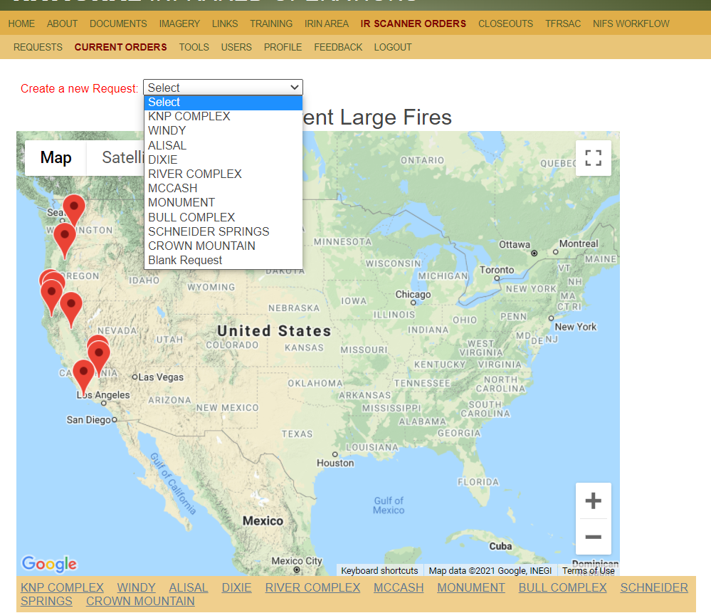
The following fields (shown with a red asterisk) must be filled with some information or you will not be able to submit the order: Incident Number, Incident Name, Project Number, and Ordering Unit.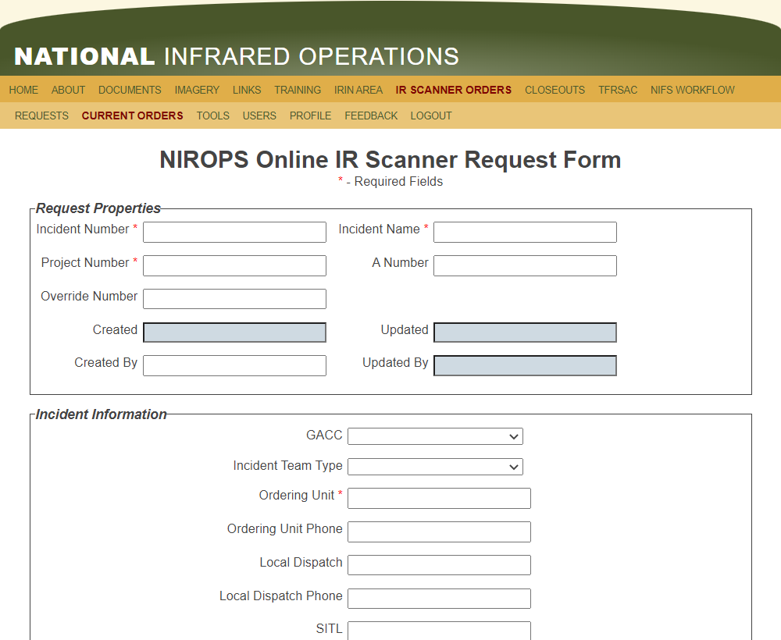
“A” Number: “A-34”. Assign in iROC.
An order can be submitted without an A# initially and added later.
P - Code:
“P5A7B4”
Override: Example “0510”
Created By: Name of person
Fill out Incident Information
Some information can be filled in by Incident or IRIN when assigned
Incident Number: “CA-MNF-7878”
Incident Name: “Fork Fire”
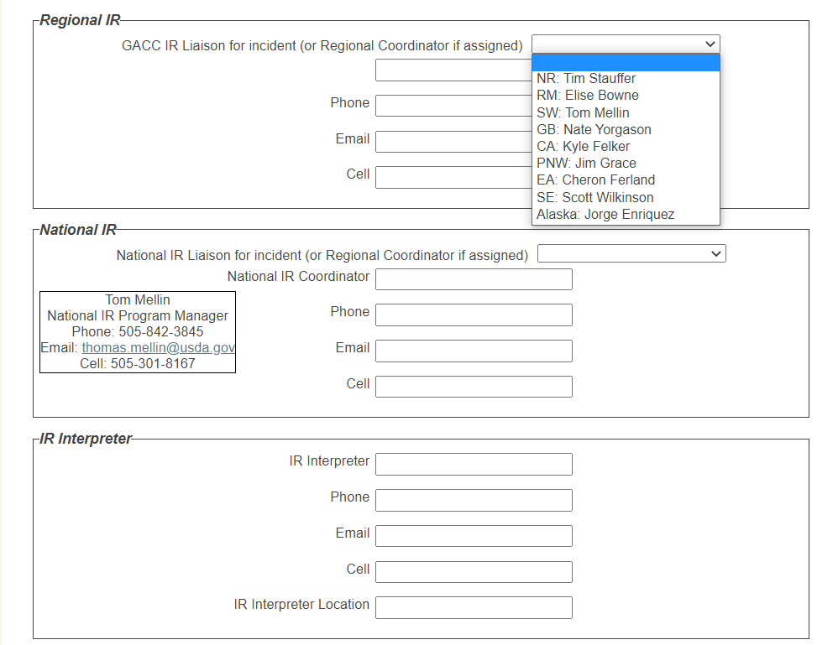
This is the IRIN who was/will be ordered.
GACC IR Liaisons:
Highlight GACC and select. Contact information will be filled in.

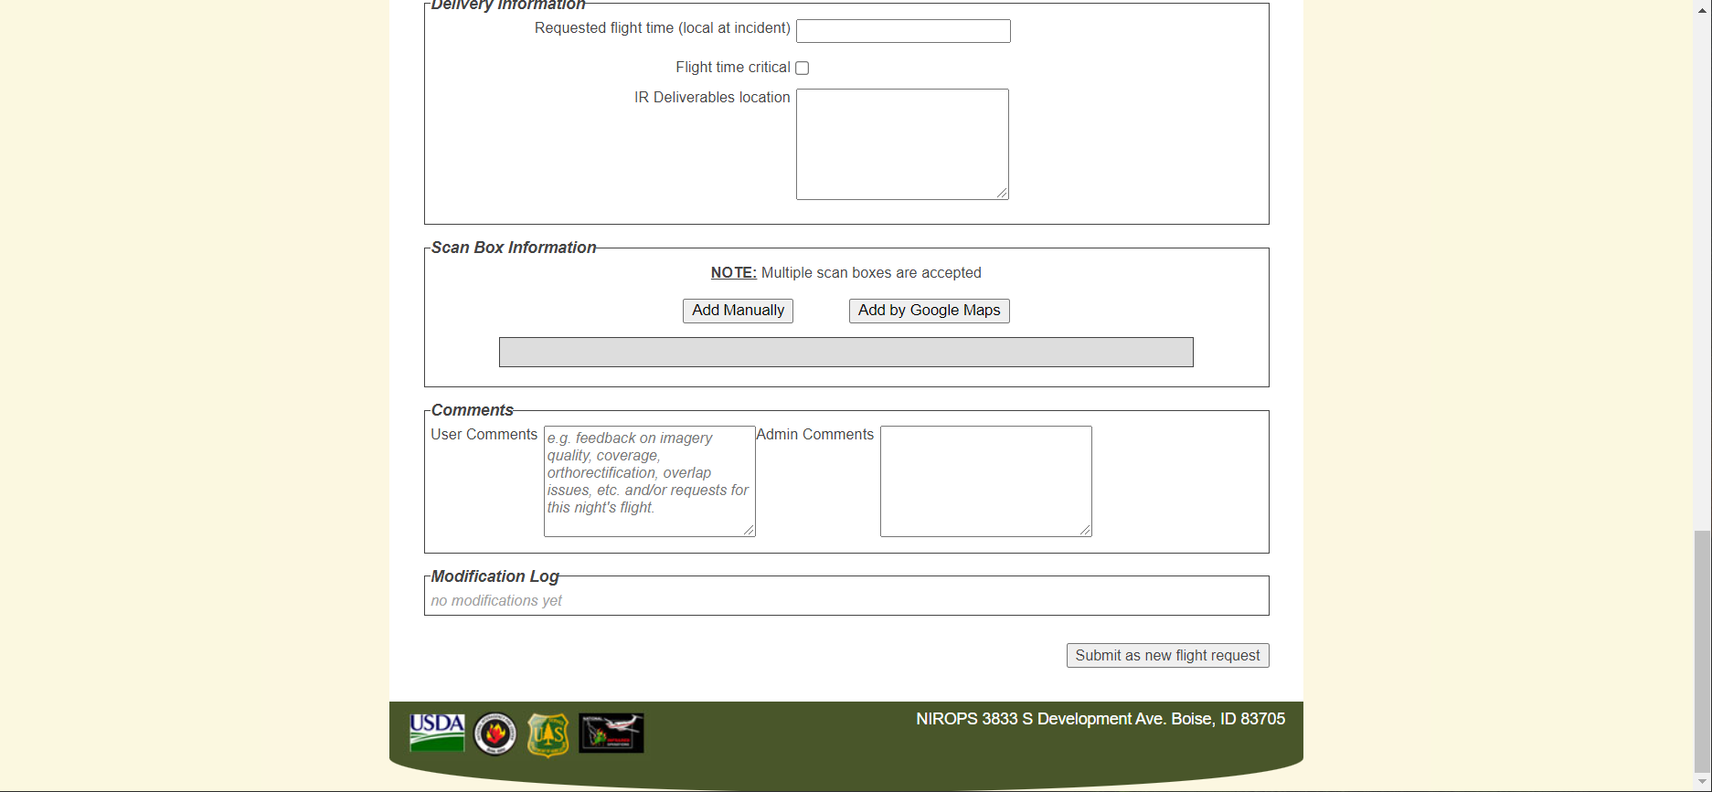
Scan Box Information:
If you have the four sides to the “BOX” around the fire you add that under “Add Manually” Go clockwise around the fire. Click on “Save”

Multiple boxes can be input per order.

A fire name must be entered. If this is a single fire, the box will be populated from the “Incident Name”.

If coordinates aren’t entered a prompt will appear.

Flight time critical:
If this box is checked, explain reason in “User Comments”.

IR Deliverables location: Typically, filled in by Incident or IRIN
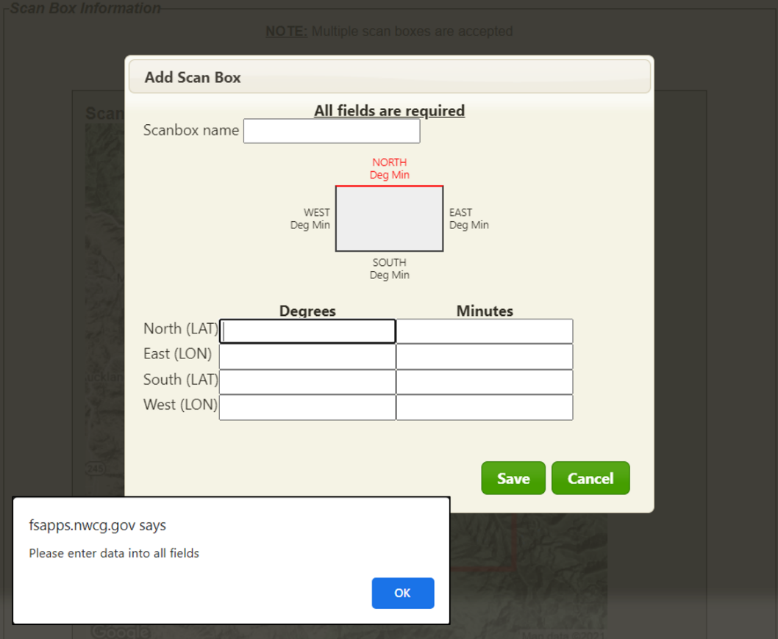
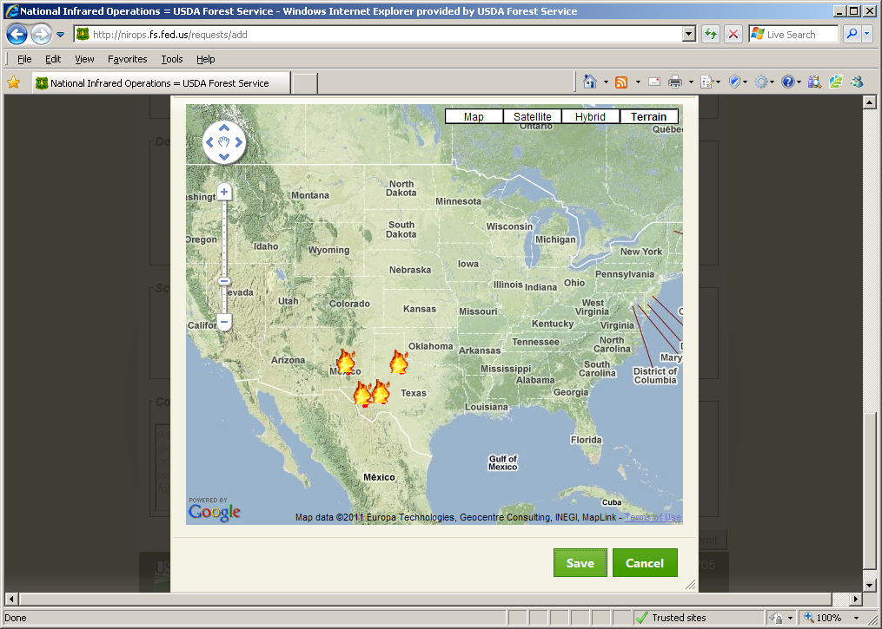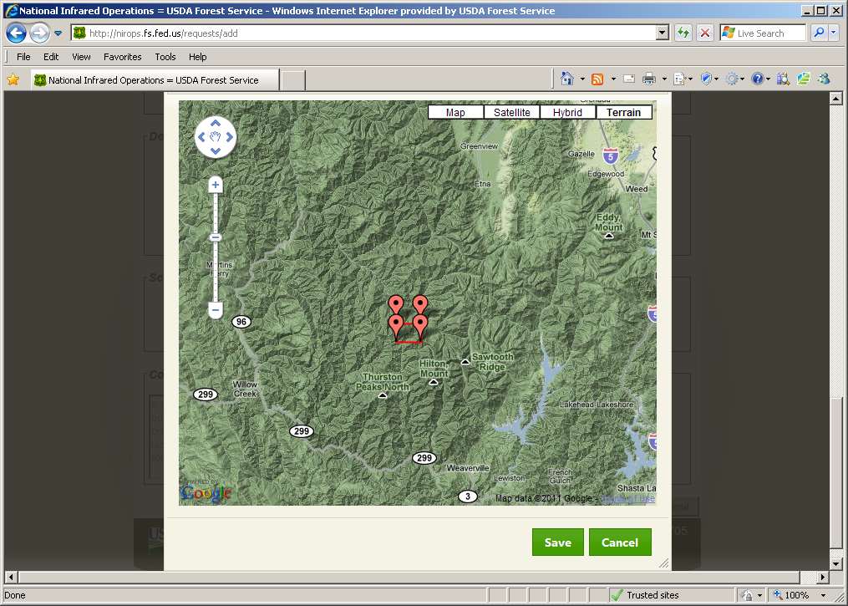
You can also draw the “BOX” with Google Maps tool. Zoom in and out and around.
Click in map area to display initial box from “Requests” (if any)
Moving the red pointers so the “BOX” covers the fire.
Lat/Lon will appear when you hover over pointers
The 0 – 6 and 0 – 12-hour MODIS detects will display in the Google Map edit box.
If there is a perimeter, it will display in the edit box.
And “Save” when you are complete
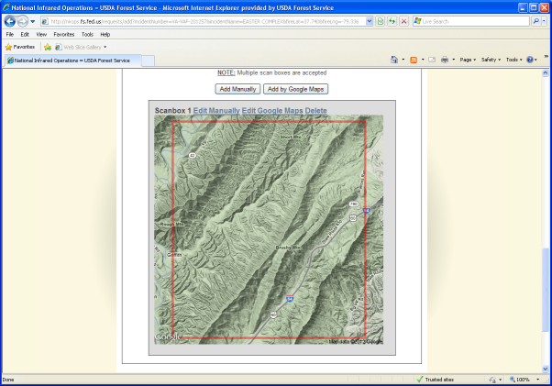
After clicking “Save” the box will display
Box displays for both “Add Manually” and “Add by Google Maps”
The MODIS 0 – 6 and 0 – 12 hour detects will display in this box
You can edit it afterwards or delete and try again.
Click in the “User Comments” box to add remarks or the reason for a specific flight time request.
On this screen you can see all the requests that have been entered for the past few days and if they have been assigned and to which aircraft.
To check the status of a request that has been entered click on “Current Orders”

Order details can also be checked from “Current Orders” page. Click “options” under “Options” and “Output PDF”
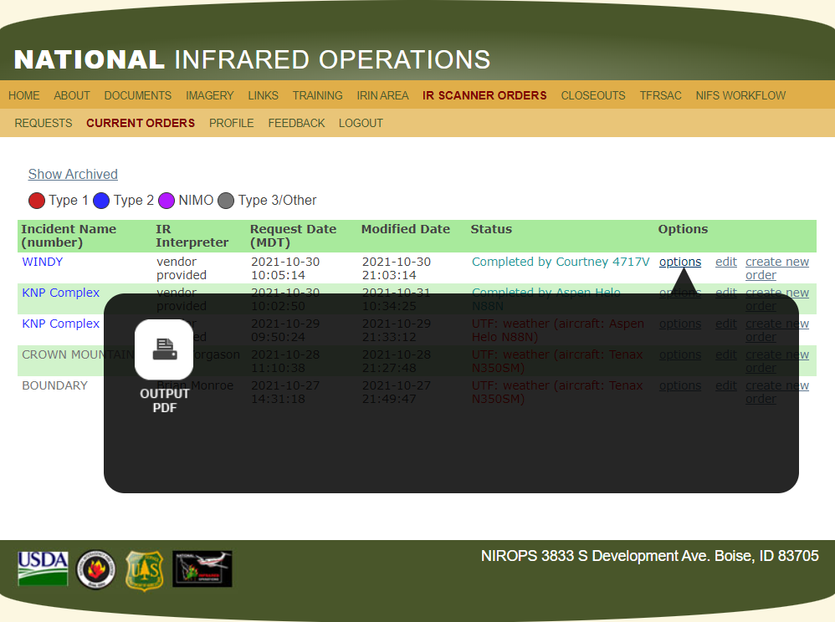
The PDF has a simple graphic with the coordinates displayed on the sides of the box

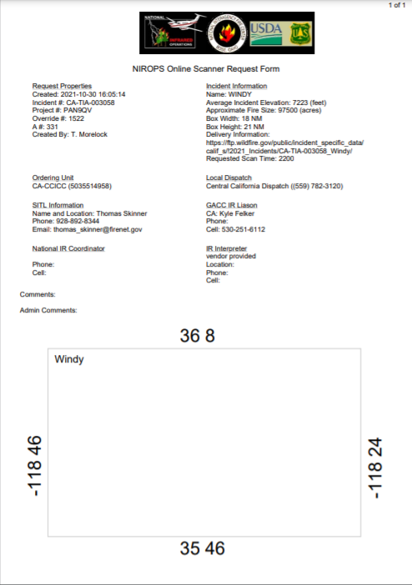

If you need to retrieve and submit an “Archived” scan order:
Go to “Current Orders”
Click on “Show Archived” to display archived orders.

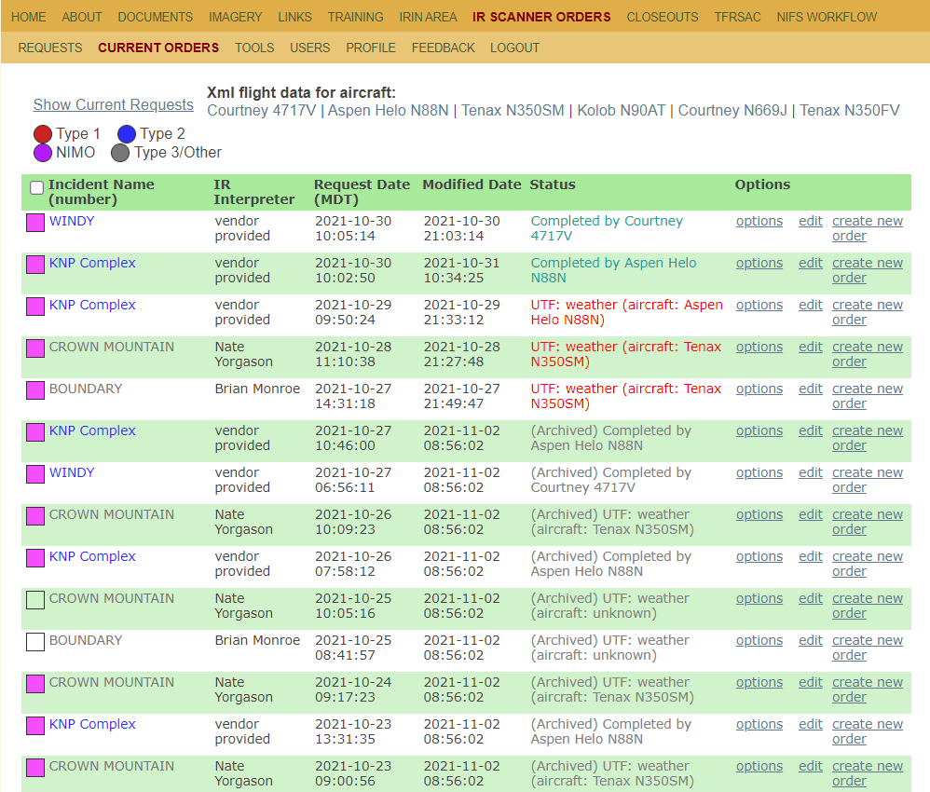
Archived orders are gray in the Status column and have “(Archived)” in the text.
Click on “create new order” for the fire of interest, make any changes, and click “Submit as new request” on the bottom of the form.

Update versus Submit: There is a difference!
Submit as new flight request:
When this is the first request for a new fire (Requests).
When this is second, third, etc. request for an existing fire (create new order).
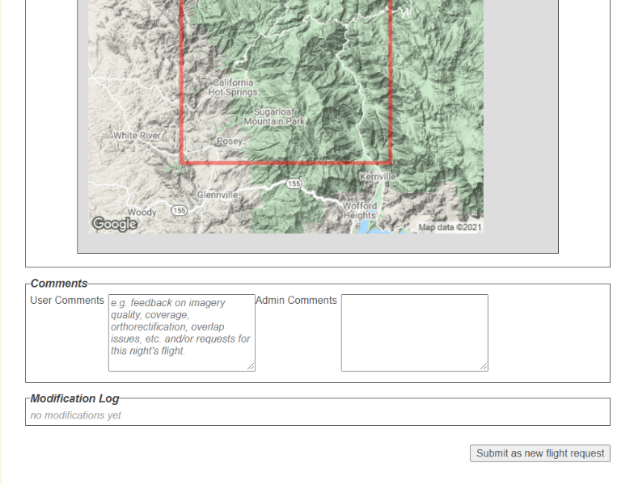
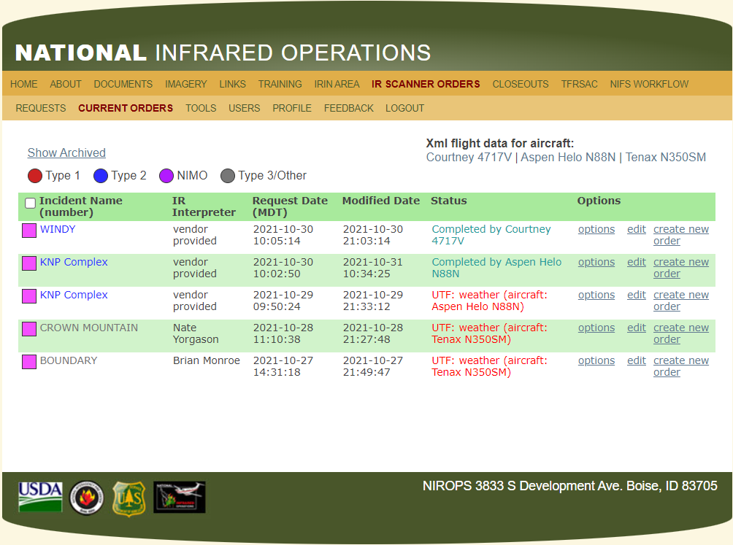
Update Existing Request:
If you change a phone number, or contact name, or add an A#, click on “edit” under “Options”.

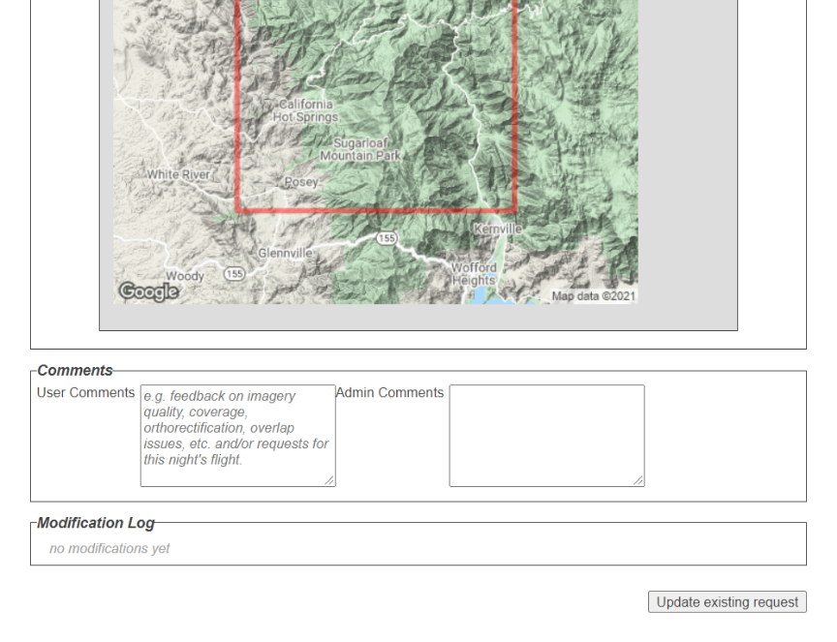
Update Existing Request:
Complete the updates, then click on “Update existing request” at the bottom of the form.

REMEMBER:
- You still need to place a request in iROC to generate an “A” number for each flight.
- IR orders must be placed every day.
- There are no standing IR orders. That is a myth!

