What IR Products Will I Receive?
If a fire is flown with NIROPS assets, the following is a list of what standard products are produced and where they can be accessed.
Shapefiles* – The following shapefiles will be produced in the projection and coordinates being used by the incident. When applicable, the incident will receive all the listed shapefiles. The activity of any given incident will influence (dictate?) the shapefiles produced, e.g. possibly no intense heat shapefile during mop up:
Heat Perimeter (polygon)
Intense Heat (polygon)
Scattered Heat (polygon)
Isolated Heat Sources (point)
* Shapefiles are typically delivered in a zip file to make sure all necessary files are transferred.
Map(s) – PDF file(s) displaying all Infrared shapefiles on a topographic map base are produced for each flight. Agreement on the desired size of the PDFs and any additional map products should be coordinated with the IRIN.
IR Log – Document that contains details of the IR Imagery acquisition and interpretation. It acts as a briefing on what the IRIN saw and was able to map from the imagery. The IR Log should identify the main areas of fire activity and growth, any sources of heat outside the mapped perimeter as well as any issues with the imagery such as cloud cover, coverage gaps, and imagery quality issues.
Location of Products
All products are placed in the IR folder under the Incident folder on the NIFC ftp site (nifc.ftp.gov). Example:
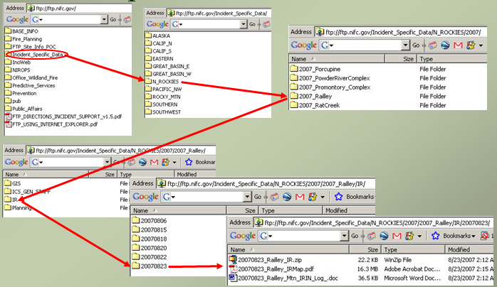
KMZ Files – In 2011 we will beta test a process for providing KMZ files of all our IR shapefiles for viewing in Google Earth. This will soon become a standard product.
Communication is key! If you need additional/different products, contact your IRIN.

