2021 NIROPS Closeout Recording
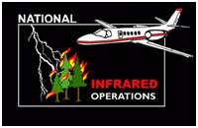

The recording of the 2021 NIROPS Closeout can be found in one of two places:
For Forest Service personnel: FS Sharepoint
For all others: https://ftp.wildfire.gov/public/nirops/NIROPS_Closeout_2021_recording/ You will have to download the mp4 file. It is about 250MB (Just under 3 hours) so use a good internet connection, preferably not wireless, and allow some time.

Presentation Timestamp
Intro (Tom Mellin) 0:00
View from NIFC (Beth Lund) 0:23
NIROPS National Summary (Tom Mellin) 0:29
Pilot’s Report (Dan Johnson) 1:05
IR Technician’s Report (Michael Mann) 1:43
GTAC Report (Jan Johnson) 2:02
Other IR Capabilities/IR Futuring (Zach Holder) 2:28

