2022 NIROPS Closeout Recording
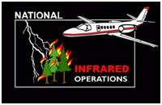

The recording of the 2022 NIROPS Closeout can be found in one of two places:
For Forest Service personnel: FS Sharepoint
For all others: https://ftp.wildfire.gov/public/nirops/NIROPS_Closeout_2022_recording/ You will have to download the mp4 file. It is about 250MB (Just about 3 hours) so use a good internet connection, preferably not wireless, and allow some time.

Presentation Timestamp
Intro (Tom Mellin) 0:00
View from NIFC (Kim Christensen) 0:05
NIROPS National Summary (Tom Mellin) 0:24
Pilot’s Report (Don Boyce) 0:52
IR Technician’s Report (Michael Mann) 1:04
Fire Imaging and IAA (Zach Holder) 1:39
GTAC Report (Will Royer) 2:15
Closing remarks/discussion 2:35

