 | Tactical Fire Remote Sensing  Advisory Committee (TFRSAC)  Spring Meeting #25 / May 24-25, 2016 | 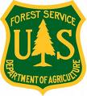

“We'll bring our eggheads, you bring yours, and we'll scramble 'em together” – Vince A.

Meeting location: NASA Ames Research Center, Bldg. 152, Mountain View, California

Moderators: Vince Ambrosia (408-666-7609 cell), Everett Hinkley (801-455-8764 cell)

TFRSAC AGENDA – Tuesday May, 24 2015

8:45 am Meeting start – NASA Conference Center (Bldg. 152) – An Adobe Connect and teleconference line are available for those who cannot attend in person.

Morning Presentations (105 minutes) All times are Pacific Time Zone
- Welcome and Introductions (30) Vince & Everett
- NASA Outlook (25) Vince Ambrosia
- Forest Service Update (20) Everett Hinkley
- View from NIFC / National IR Program Manager (20) Tom Mellin
- CalFire Update (25) Jana Luis

10:45 am Break (15 min)

11:00 am Breakout Session – Future Direction of TFRSAC (Leads: Vince & Everett)

12:00 pm Lunch – Sandwich Bar

1:15 pm Afternoon Session #1 (115 minutes)
- The sensitivity of US wildfire occurrence to pre-season soil moisture conditions across ecosystems (25) Brittany Zajic
- Multi-UTM Concept of Operations (25) Ed Freeborn
- Update: Hawkeye Fire Detection & Reporting (15) E. Hinkley / Sean Triplett
- Cubesats for Earth Science Applications (25) Sreeja Nag
- Natural Resources Canada – Update (25) Tim Lynham

3:10 pm Break

3:25 pm Afternoon Session #2 (95 minutes)
- NASA Wrangler (25) M. Carroll & J. Schnase
- AMS Update (20) Brad Quayle
- Sensors, real-time dissemination and UAS (25) David Yoel
- FireFlight Aerial Fire Mapping System (25) R. McCreight / P. Dare

5:00 – 5:20pm Report outs on Breakout Session - Adjourn for day

6:45 pm Meet for dinner

Day 2 Agenda – Wednesday May, 25 2015

9:00 am Meeting start // Location: NASA Conference Center (Bldg. 152)

Morning Presentations (105 minutes)

- Tuesday Recap / Breakout Session Summary (10)
- FASMEE and UAS (25) Adam Watts
- Fire & Smoke Model Eval. Experiment (FASMEE) (25) W. Schroeder / M. Dickinson
- Fire Monitoring & Assessment Platform (25) Dale Hamilton - NNU

12:15 pm Lunch (1 hour 15 minutes)

1:30 pm Action Items and Wrap-up

2:00 pm Tour: NASA Airborne Sensor Facility // NASA-Ames UAS Facility Hanger

5: 00 pm Adjourn

6:45 pm Meet for dinner

TFRSAC Meeting Adobe Connect session
https://ac.arc.nasa.gov/tfrsac/

Telecon information:
Number: 1-844-467-4685
Passcode: 750362#

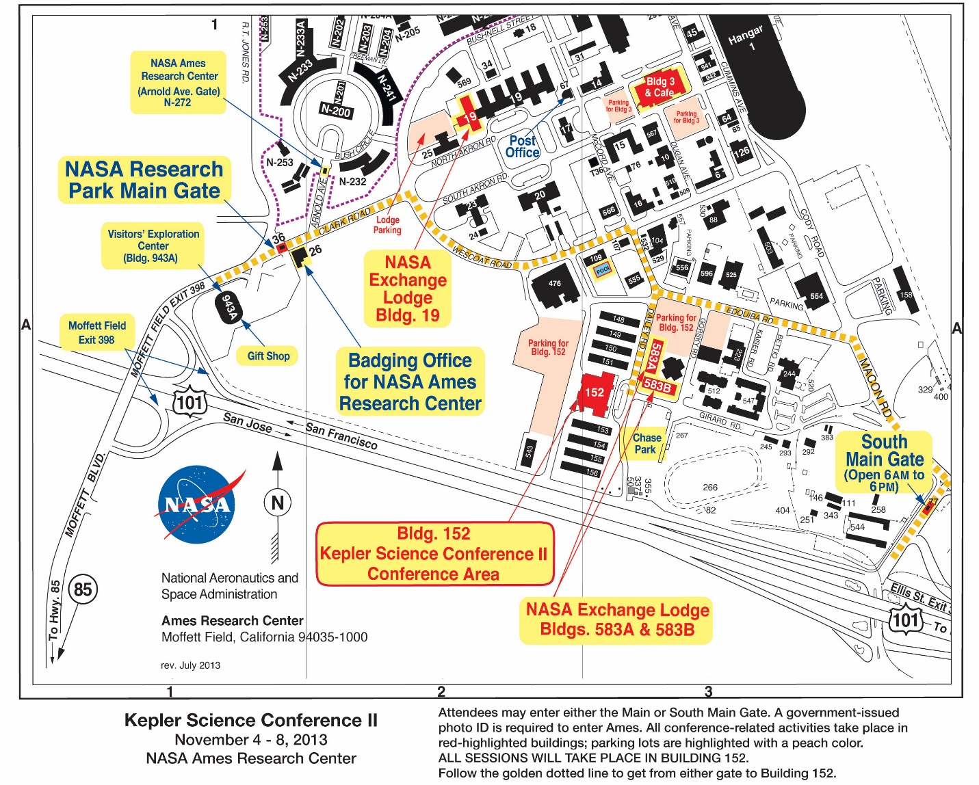

Logistics at Ames

- WIFI: Those coming to the meeting will be issued a NASA Guest Wireless Account login.
- Lodging: The map above shows the NASA Ames facilities (meeting facility is Bld 152, ballroom); NASA LODGE (check-In) is Building 19, while the delegates may be staying either in Bld 19 or Building 583-A / 583-B. ALL need to check-in at Bld. 19 and get their key. Please provide the map in the mailing, so all can locate the meeting building and other services.
- Badging: The NASA front gate has changed location (it is farther into the base by 150 yards than the original gate). For the visit the sensor shop and UAS hanger on Wednesday afternoon, we will all to get a NASA Access Badge (otherwise not needed for access to the Lodge or the meeting facility). Badging is done at the same Visitor Check-In Building at the outer perimeter gate (the building that it has always been in);
- MEALS - On base meal service: continental breakfast, lunch: make-your-own deli sandwich bar, drinks and afternoon snack are provided;
- After Hours: Tuesday night will be a group get-together for dinner at the Tied House.
- Wed. night dinner is on your own, or we can gather up those staying and go into Mountain View.

